April 20, 2021

Honorable Mikie Sherrill, Chairwoman Honorable Stephanie Bice, Ranking Member
Subcommittee on Environment Subcommittee on Environment
Committee on Science, Space, and Technology Committee on Science, Space, and Technology
U.S. House of Representatives U.S. House of Representatives
1414 Rayburn House Office Building 1223 Longworth House Office Building
Washington, DC 20515 Washington, DC 20515

Dear Chairwoman Sherrill and Ranking Member Bice:

The Association of State Floodplain Managers (ASFPM) greatly appreciates the attention which the Committee on Science, Space and Technology, and especially the Environment Subcommittee, are actively placing on seeking improved Federal investment and coordination of climate risk-related information that will support States, territories, communities, and tribal governments, their citizens, the private sector, and other federal agencies, in planning, designing, and managing infrastructure and their long-term health and community resilience, especially in light of the increasing hazards and risks of climate changes.

The 20,000 members of ASFPM and our 37 State Chapters work with all federal agencies and at the state and local levels nationwide in reducing loss of life and property due to flooding. State and local floodplain managers and their private sector, academic, engineering and floodplain management colleagues and other professionals are engaged in all aspects of flood risk management and flood hazard mitigation, including management of local floodplain ordinances, flood risk mapping, engineering, planning, community development, hydrology, forecasting, emergency response, water resources development, protection of valuable floodplain functions, and flood insurance and are active at all levels in developing and implementing solutions to flooding challenges.
Experience continues to demonstrate that the increasing variability and frequency of intense weather events and conditions, along with intensifying watershed development and aging water infrastructure, all underscore the need for improved information, predictive science and new approaches to reduce vulnerabilities and increase resilience. The year 2020 has again demonstrated the increasing risk and costs associated with severe weather and natural hazards, with a record 22 natural hazard disasters costing more than a billion dollars each. The National Centers for Environmental Information has identified some 291 such events having occurred since 1980, with a cost of more than $1.9 trillion, and floods are – and continue to be – the nation’s most frequent and costliest disasters, and the costs to taxpayers continue to increase. Thus, the importance of generating and making widely available authoritative and future conditions prediction science is essential to anticipate and adapt to changing conditions, and the need for such services to be widely shared and distributed has never been more critical for all of our nation’s communities, heading into the future.
ASFPM also strongly applauds the two bills H.R. 1438 and 1437, the FLOODS Act and the PRECIP Act, respectively, recently reintroduced by Chairwoman Sherrill and bipartisan cosponsors to directly address and improve interagency water resources coordination and to provide best available, up-to-date and future climate conditions science data on water, extreme precipitation frequencies, and flood hazards risks going forward into the future. ASFPM is especially concerned that nearly all of NOAA’s NWS’ Atlas 14 volumes have fallen far behind, most 10 – 20 years behind, and in the Pacific Northwest, the Atlas is nearly 50 years out of date in incorporating precipitation records, and yet many engineers, planners and design professionals must struggle to use these tools that in almost all instances are under-estimating extreme precipitation that is increasing from climate change and global warming. These same NOAA documents are critically important input sources for mapping the nation’s floodplains through FEMA’s National Flood Insurance Program. Early passage of either or both of the FLOODS Act and the PRECIP Act will provide critical support to NOAA and the NWS to generate and distribute the data that must be considered foundational to any national infrastructure modernization for the 21st Century. A recent Washington Post article demonstrates the importance of and enormous future cost savings to taxpayers and the economy that such legislation would provide.
Again, thank you for the opportunity to share our thoughts. Please contact me should you have any questions: cberginnis@floods.org or (608) 828-3000.
Very respectfully,
Sincerely,
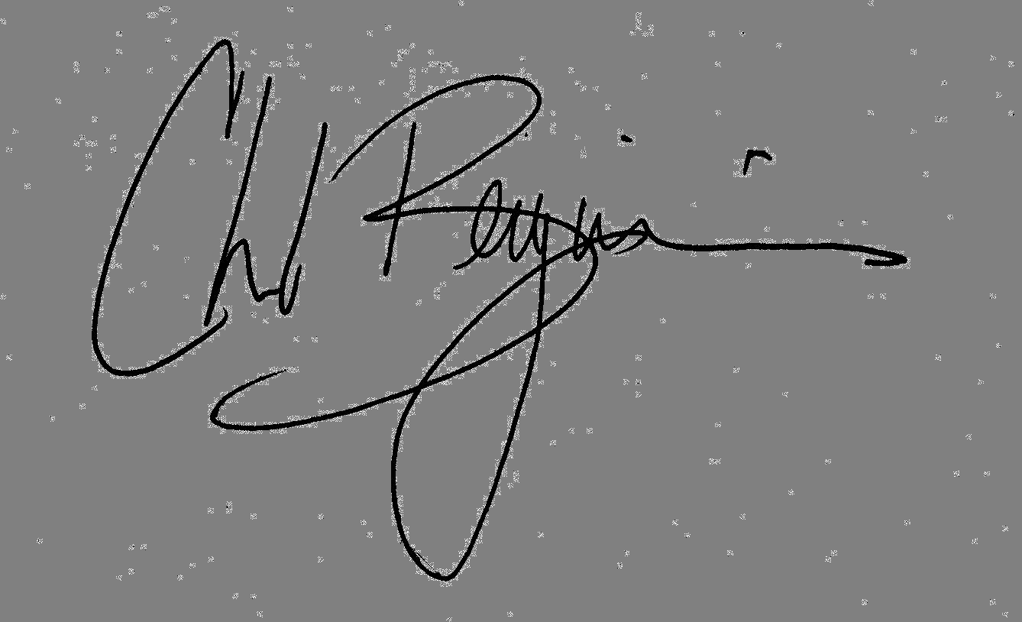

Chad Berginnis
ASFPM Executive Director

