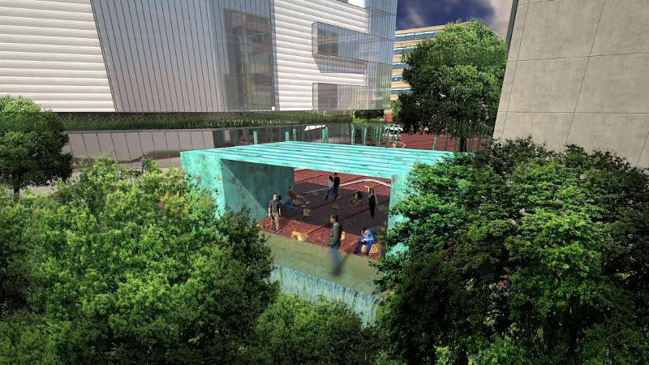
Van Ness Vision Committee
Report 2013-2014
January 31, 2015

Van Ness Vision Committee
of Advisory Neighborhood Commission 3F
Report for 2013-2014

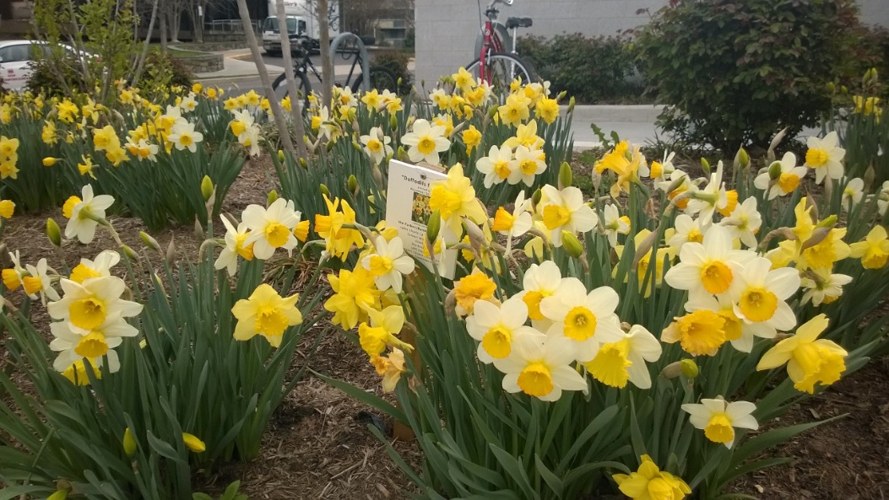

Executive Summary
- Less than two years ago, a community of volunteers established the Van Ness Vision Committee under the auspices of Advisory Neighborhood Commission 3F.
- The Van Ness Vision Committee (VNVC) works with commercial property owners, merchants, schools and universities, city agencies, neighbors and others to make the Connecticut Avenue corridor between Van Ness and Albemarle Streets more beautiful and more vibrant.
- The VNVC has actively reached out to developers, merchants and others in the business community to convey that Van Ness is open for business, and that we aim to create value together.
- To create meaningful and lasting changes, the VNVC needs a management structure.
- The Main Street model suits the size and mission of the VNVC, and the group is currently pursuing 501(c)(3) status, legislation at the DC Council, and an application for Main Street designation.
- Meanwhile, the VNVC will continue its efforts to make Van Ness more beautiful and more vibrant.

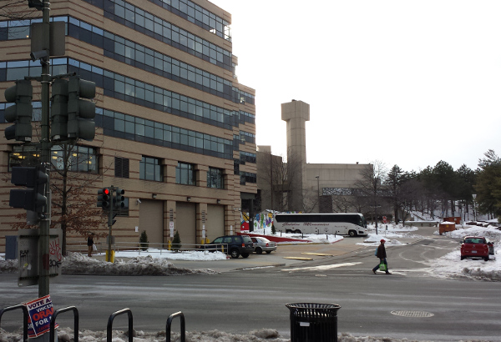

How it all started
It all started with a walk. Marlene Berlin coordinated that walk in October 2012 with the DC Office of Planning and the Coalition for Smarter Growth, and to everyone’s surprise, a group of over 100 neighbors gathered on a bitterly cold day to stroll the Van Ness/Connecticut Avenue corridor and identify what works and what doesn’t work. Most comments that day focused on the negative: too much concrete, dated architecture, a need for more trees and low impact design, and a sense that retail was underperforming. But the message from that walk was clear: while the Van Ness commercial corridor is underachieving, it possesses enormous potential, and neighbors will work tirelessly to make it better.
The idea for the Van Ness Vision Committee evolved from that desire. The VNVC was formed by unanimous resolution at the ANC 3F meeting on February 19, 2013. The purpose of the ad hoc committee is to build momentum in the community to work together with commercial property owners, businesses, schools, city agencies and others to make our stretch of Connecticut Avenue more beautiful and more vibrant.
In short, Van Ness is open for business!
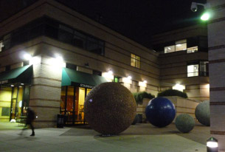
Members and Meetings
The Van Ness Vision Committee membership represents a broad slice of our diverse neighborhood. Three members live in apartments or condominiums next to Connecticut Avenue. Others reside in single-family homes in Forest Hills or North Cleveland Park. Some are single, others are married. Ages range from 30s with young children, to 80s with grandchildren. Careers also reflect a broad spectrum, with Washington’s usual generous dose of lawyers, an economist, a conservation biologist, a university professor and dean, an architect, an interior designer, a strategy consultant, a retired World Bank event planner, and the founder and editor in chief of our neighborhood e-magazine, The Forest Hills Connection, among others.
VNVC members include David Bardin, Marlene Berlin, Patricia Davies, Lawrence Rausch, Charles Schilke, Marjorie Share, William Sittig, Jane Solomon, Judith Sullivan, Ken Terzian, Frances Wu, ANC 3F Commissioners Sally Gresham, Karen Perry, Mary Beth Ray, and ANC 3F Chairman Adam Tope. Commissioner Mary Beth Ray chairs the committee. Dipa Mehta and Travis Price serve as advisors to the committee. Rachel Huhn assists the committee as needed.
The Committee held 18 regular monthly meetings, which were announced at ANC meetings and were mostly held at UDC: 4/12/13, 5/10/13. 6/14/13, 7/10/13, 9/13/13, 10/11/13, 11/8/13, 12/13/13, 1/10/14, 2/3/14, 3/27/14, 5/31/14, 6/24/14, 7/25/14, 9/5/14, 9/20/14, 10/17/14, and 12/5/14. Meeting dates and times alternated weekdays and weekends, mornings and evenings, to appeal to a wider audience. Subcommittees met more often. Highlights of each VNVC meeting were reported at ANC meetings; events, news and activities were publicized in the Forest Hills Connection.

Vision Statement

Soon after its formation, the VNVC adopted a Vision Statement:
- Connecticut Avenue at Van Ness will blossom into a beautiful, sustainable tree-shaded avenue that highlights and invites connections with Rock Creek Park and retail life.

- It will be accessible by Metro, foot, bicycle & motor vehicle, with outdoor cafes, markets, restaurants, activities, events & the arts.

- It will draw on its residents with its extraordinary community of embassies, schools, universities & businesses.

- Its next big goal is to grow a vibrant commercial & cultural street life.

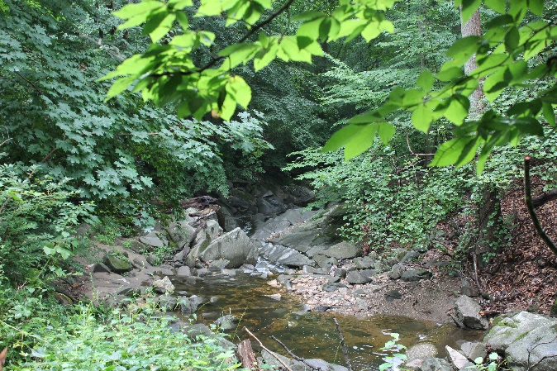
Soapstone Valley trails reward hikers with a pristine forest and a rushing stream, leading to Rock Creek Park. Managing storm water runoff and erosion are important components of Van Ness development to preserve this natural beauty. Photo by Alex Ray

Vibrant Retail Streets Workshop
Berlin and Ray applied to participate in the Vibrant Retail Streets Workshop on behalf of Van Ness, and their application was accepted. The workshops on June 12 and July 24, 2013 were run by Street Sense, and attended by Ray, Berlin, Zach Friedlis (Asst. VP, Saul Centers, Inc.), Andrea Limauro (then our Ward 3 Planner) and representatives of several other DC neighborhoods. The workshop yielded important information:
1. the need to create an organization to manage the street
2. renderings of the avenue at Yuma Street (see appendix)
3. and data—demographic, lists of businesses and property owners, maps of businesses and classification of retail space (see appendix)

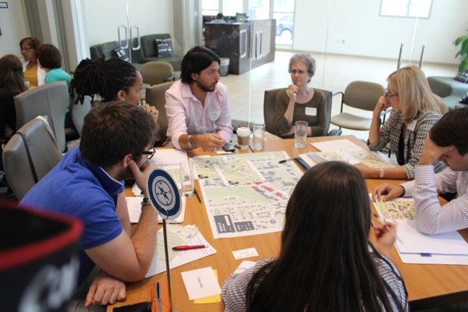

The Vibrant Retail Streets Workshop, including former Ward 3 Planner Andrea Limauro, Marlene Berlin (Forest Hills Connection and VNVC), Mary Beth Ray (VNVC Chair and ANC 3F3 Commissioner), and Zach Friedlis (Asst. VP, Saul Centers, Inc.)

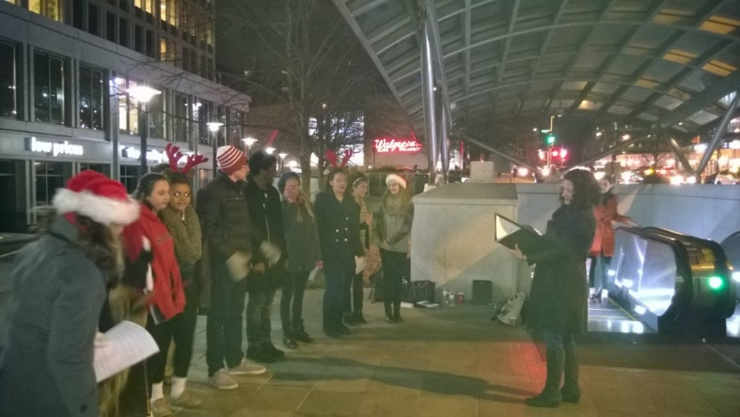
Carolers on Connecticut, Dec. 2014, St. John’s College High School and University of Maryland singers performed at the Van Ness Metro, Giant, Bread Furst, Calvert Woodley and Acacia Bistro to the delight of evening commuters

The Office of Planning and Street Sense team encouraged us to focus on what’s special about Van Ness. Here’s a partial list:

- Metro & Walkability; surface and garage parking; BikeShare

  - Rock Creek Park access through Soapstone Valley Park trails
  - Farmers’ Markets (in season)
  - Large plaza spaces for markets, concerts & events
  - Universities and schools (UDC with Theater of the Arts &
Amphitheater, Levine School of Music, Franklin Montessori, two major law schools)
- Highly desirable DC Public School district (Murch/Hearst, Deal, Wilson)

  - Hotel and small local businesses
  - WAMU broadcast studios
  - Abundance of offices, apartments and homes
  - International community, embassies, mix of ages and cultures
  - New retail
  - Engaged, friendly community
  - Great potential for vibrant, mixed use street life, daytime and evening
Activities and Work

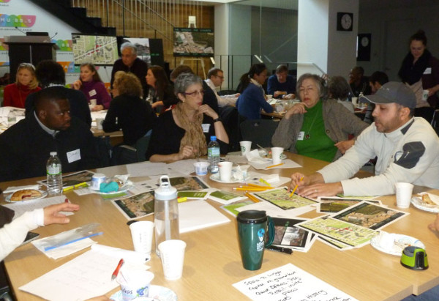
Our first community design charette March 8, 2014 hosted in the beautiful new WAMU studios and led by Travis Price drew a big crowd of eager participants
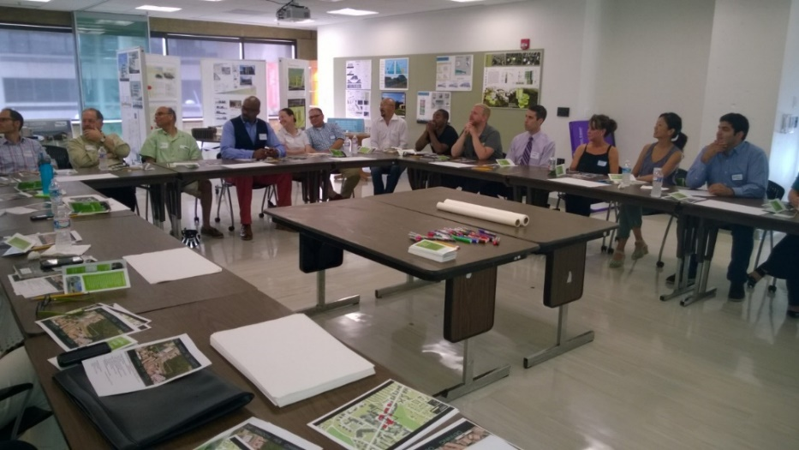
Our second design charette held on July 19, 2014 at UDC’s School of Architecture
- The group formed early connections with stakeholders, including commercial property owners, merchants, UDC, Fannie Mae, WAMU, the DC Office of Planning, DDOT, DDOE and others.
- The VNVC and other neighbors planted daffodils on Nov. 16, 2013, which was a great example of community involvement, and a partnership with Sandy Farber Bandier of UDC, who generously donated the bulbs in honor of her father, and Alex McCarthy of John Shorb Landscaping, Inc., who donated supplies and time to help organize the volunteer crew of about 30 people. The bulbs cooperated with a splendid showing in spring of 2014, announcing to the community to ‘watch this space’ for more good things to come.
- Links with UDC included the use of meeting space, and CAUSES. The VNVC presented its strategy to the UDC Board of Directors, and meets regularly with UDC’s VP of Real Estate, Barbara Jumper. VNVC invited CAUSES Dean Sabine O’Hara to address the group, we participated in DC Green, and visited the UDC CAUSES farm in Maryland. UDC faculty and staff participated in numerous VNVC activities and forums, and VNVC coordinated with area theatre groups, Politics and Prose, Washington Ballet and others to view the UDC Performing Arts theatre as potential space. Meetings continue to determine how to use rainwater collected in UDC reservoirs to water flowers planted in Van Ness public space.
- Our first Meet & Greet with commercial property owners, UDC representatives and others (about 30 people) was held February 20, 2014 at the home of architect and advisor Travis Price. A Power Point presentation highlighted goals of the VNVC and how to get involved.
- On March 8, 2014, VNVC and WAMU co-hosted a Charette, led by Travis Price, to brainstorm with the community how to make Van Ness more beautiful and more vibrant. The Saturday morning turnout of 60 neighbors huddled in teams over poster paper, markers in hand, ideas flying, yielded themes for a Windom Place Hub—participants clearly hoped to echo themes of nature, rock, water and trees, in a community gathering place that highlights the arts and offers recreational activity.
- On July 15, 2014, the ANC passed a unanimous Resolution to commission architect Travis Price to draw a conceptual rendering of what the Windom Hub might look like. An award of $10,000 was made to compensate Price’s team for the design time.
- A follow up Design Charette was held at UDC July 19, 2014, with landscape architects, architects, UDC architecture department staff, and other design professionals (about 30 in all). Continuing emphasis was placed on nature, connections with Soapstone Valley Park, and UDC, and lively discussions yielded more ideas.
- At the November 18, 2014 ANC meeting, Price revealed his design to the community.
- And on November 19, 2014, a second Meet & Greet was held at UDC’s Window’s Lounge, to introduce Price’s design concept to the business and development community (about 60 attendees).
- Several follow up meetings have been held with DDOT to discuss the viability of the plan, potential funding, and coordination with the Office of Planning’s Van Ness Vision Framework effort, spearheaded by Ryan Hand, our new Ward 3 Planner.
- On January 20, 2015, ANC 3F passed a resolution to renew the Van Ness Vision Committee for another 2 years, continuing its status as an ad hoc committee.

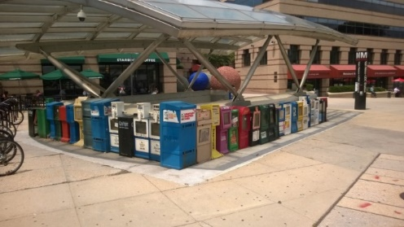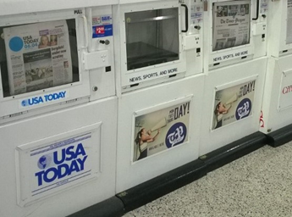
The newspaper dispensers now; and the newspaper “condominium” we hope to implement
Short-term Projects:
- To engage small businesses the VNVC is promoting Great Streets Grants— with the help of Dipa Mehta, Bread Furst applied and won the maximum $85,000 grant. The funding by DC’s Office of the Deputy Mayor for Planning and Economic Development is designated for use in the completion of certain capital improvements to the business. The capital projects proposed by Bread Furst include the acquisition of key bakery equipment (which will allow for greater and more variety of production), exterior improvements to the sidewalk café area, and interior changes that will increase seating and shelf space. These projects are to be completed by August 2015.
- Committee members regularly walk the avenue to distribute relevant community and grant application information to merchants.
- Tidying up existing newspaper dispensers, while seeking new ones
- Watering Partnership with UDC and Connecticut Avenue Clean Team—use of their water from cistern starting in spring to water tree boxes and planters
- Parking project to identify and mark useable parking spaces, both surface and garage
- Performing Arts at Van Ness through monthly musical events—Jazz Alive, November 13 and Caroling on Connecticut, Dec. 18
- Programming the UDC Performing Arts Theater and the Amphitheater- meetings with UDC VP Real Estate, and management of theatre, plus Washington Ballet, Levine School of Music, Washington Performing Arts, Politics & Prose and others.
- Creation of a brochure and power point presentation to market Van Ness to potential developers and merchants (“Creating Value Together”)
- Brainstorming recreational activities to draw people to Van Ness from our community and beyond. Ideas include reviving the historic ice rink, miniature golf with a course that resembles Rock Creek Park, bocce, beach volleyball, and even a zip line.
- Meetings with Mayor Gray’s International Embassy Liaison, ideas to partner with embassies for entertainment/food and perhaps yoga or Tai Chi classes
- Meetings with Fannie Mae, WMATA and Polinger Co. to discuss use of plaza space near Metro for performing arts, exercise classes, plantings or visual arts.
- Johns Hopkins Carey School of Business Real Estate graduate students, and UDC’s School of Architecture students both took on the challenge of redesigning Van Ness. Both emphasized the Windom Hub as a potential gathering place for the community and the performing arts, and our connection to Rock Creek Park through Soapstone Valley Park.

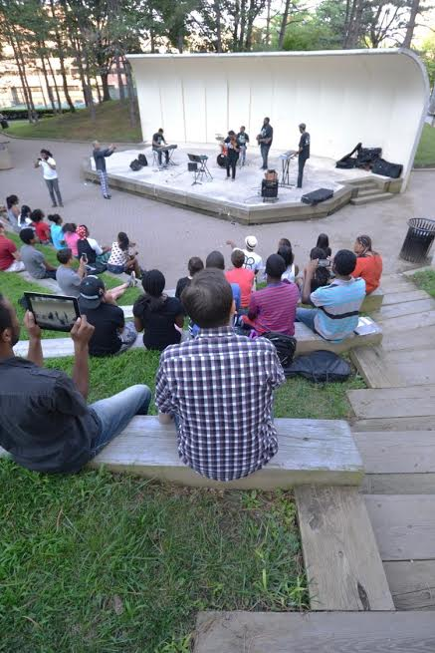
The UDC amphitheater is a hidden gem (photo courtesy Travis Price)

Search for a Management Structure—to take us to the next level
While the Van Ness Vision Committee has taken great strides to start momentum to bring beauty and vitality to our commercial corridor, we need a management structure to implement big and lasting change.
- Business Improvement District or BID— In the course of several meetings with Ann Marie Bairstow (former DC BID Council Executive Director), Joe Sternlieb (President, Georgetown BID), and Heather Arnold (Managing Director of Public Sector, Street Sense), it is apparent that not only are we too small for a BID, but at this point, momentum is mainly from the community. For a successful BID, the momentum needs to come from the business community.
- Forest Hills Neighborhood Alliance and Citizens Association—We met with Denise Warner (President, FHCA and FHNA) to discuss a possible merger with the FHNA, but their mission is narrowly defined and would not accommodate our broader effort.
- Small Area Plan (SAP) and Meeting with Office of Planning- zoning changes are not required at this point, so an SAP doesn’t appear to be correct vessel.
- Main Street—Numerous conversations with Bill McLeod (head of DuPont Circle Main St.) and Cristina Amoruso, DSLBD, point us in the direction of the Main Street paradigm. This model fits us because of our size, who we are at this point, the work we want to do with developing the Windom Hub, events and beautification projects, and the Office of Planning grant. We have received a commitment from Councilmember Mary Cheh, who supports our Main Street efforts, and who intends to introduce legislation at the DC Council for the creation of a Van Ness Main Street. In anticipation of that next stage, we are working to organize the VNVC along the lines of the Main Street four-prong model: organization, design, economic and promotions. We are working with Adam Tope and Akin Gump LLP to form a corporate entity, and to apply for 501(c)(3) status, which will enable us to apply for Main Street status.
- Office of Planning “Van Ness Vision Framework Advisory Committee”—Seeing the momentum building in Van Ness, the DC Office of Planning has launched a parallel, but coordinated effort in the “Van Ness Vision Framework Advisory Committee”. OP has secured a grant to survey infrastructure below ground to determine the possibilities for above ground improvements, whether that be planting trees, building low-impact development infrastructure and landscaping, or other projects. Several VNVC members serve on the advisory committee of the OP project, and the Ward 3 Planner, Ryan Hand, is included in VNVC meetings and events. Through this committee, OP hopes to assess our Van Ness community’s needs and invest city money to enhance sustainable streetscape improvements and encourage a more vibrant retail environment. A strong and positive working relationship with open communication between the two groups will ensure that there is not duplication or confusion.

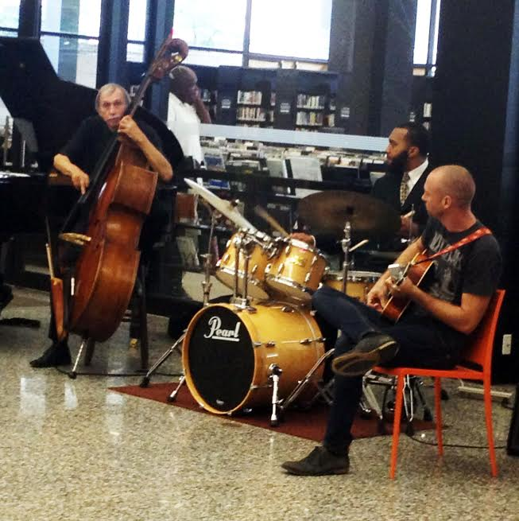
UDC’s Jazz Alive at Acacia Bistro, our first Music at Van Ness Series
Recommendations
- The Van Ness Vision Committee ad hoc status should be renewed by ANC 3F so that it can continue its work and momentum toward a managed street. (Done, ANC 3F meeting January 20, 2015, by unanimous motion)

- The VNVC should reorganize into committees that track the committee structure of Main Street organizations. (Underway)

- New VNVC committees should be chaired by VNVC members, and every effort should be made to reach out to the community to broaden membership to a wider, yet committed, group.

- Ongoing initiatives on programming, ie monthly Music at Van Ness, should continue.

- Programming subcommittee should approach commercial property owners, merchants and community for donations to fund a consultant to help organize Music at Van Ness series, and to pursue grants that can be used to pay an organizer, and musicians.

- Ongoing initiatives relating to beautification, ie planters and newspaper boxes, should continue.

- Committee should continue to explore possible recreational activities that would fit the size and personality of Van Ness, and that would draw neighbors as well as visitors from other communities. The activities should appeal to a broad range of ages, from young children and teens to adults.

- Continue coordination with Office of Planning “Van Ness Vision Framework Advisory Committee”, have VNVC chairs attend Framework meetings, and include Ryan Hand in VNVC meetings.

- Continue to work with Framework team to identify ways to incorporate low-impact development, particularly with regard to planting trees, engineering sustainable tree boxes, and minimizing storm water runoff and erosion that contribute to the decline of Soapstone Valley Park.

- Draft timeline showing next steps with regard to establishment of corporate status, 501(c)(3) application, DC Council legislation supporting Main Street establishment, and application for Main Street status.

- Complete creation of corporation, bylaws and articles of incorporation, and 501(c)(3) application.

- Begin drafting Main Street application.

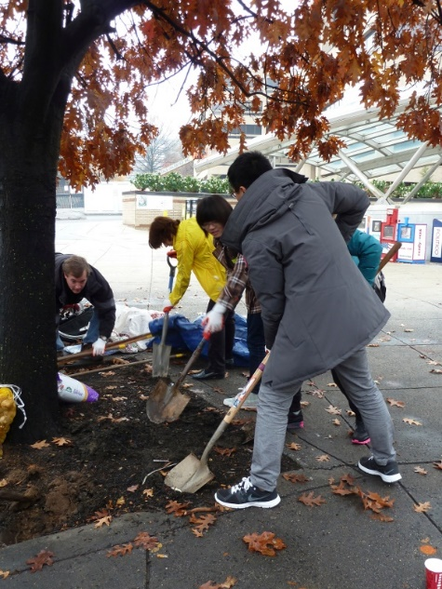 All hands on deck for the daffodil planting!
Summary
Our daffodil planting project is an apt metaphor for the Van Ness Vision Committee. Months in advance, much hard work is going on behind the scenes, digging, tilling the soil, fertilizing and watering. Months go by, and nothing seems to be happening. And suddenly one day the glorious flowers burst forth.
The Van Ness Vision Committee continues to toil behind the scenes, and while we hope to bring regular musical programming and more plants to Van Ness, the big changes will not be apparent for some time. However, with a management structure, an executive director and board of directors, investment by the city and commercial property owners, and the ongoing tireless efforts of community volunteers, Van Ness will blossom!
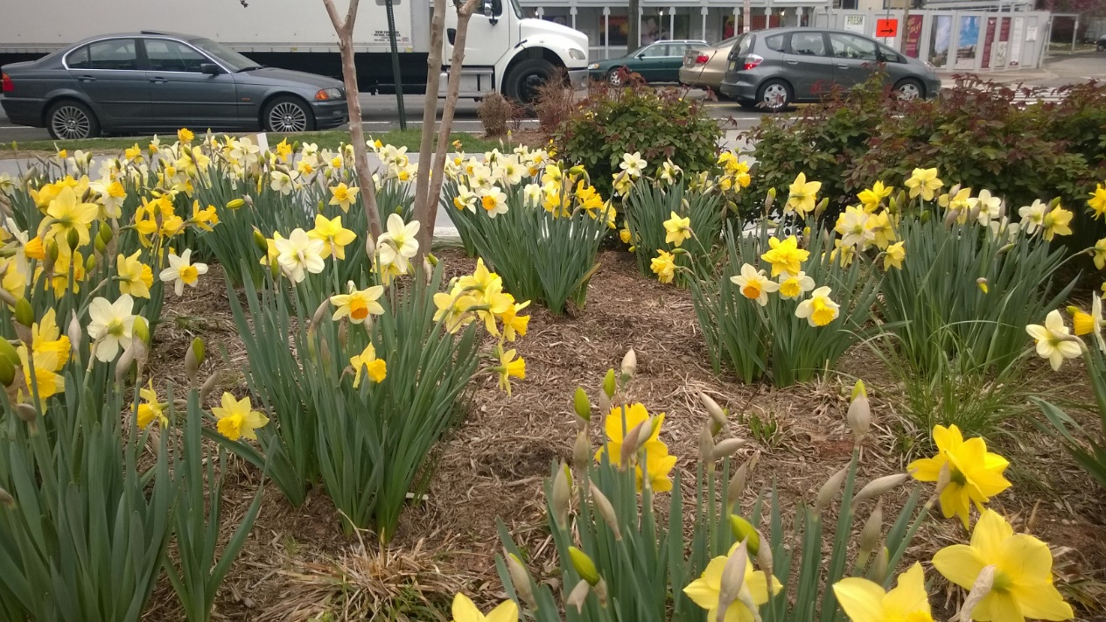

Appendix

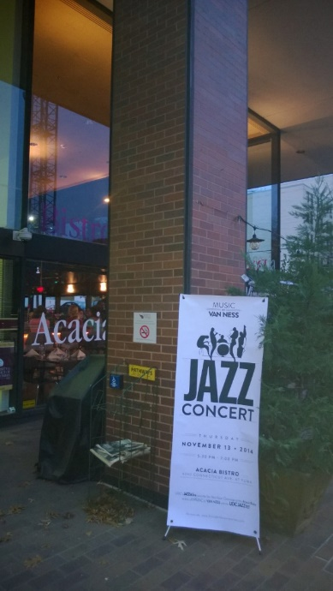
Jazz Concert at Acacia, first of the Music at Van Ness Series, Nov. 2014

Merchants, Property Owners and Others with whom the VNVC has worked:

601W (Intelsat owners)
Acacia
ANC 3F Commissioners
Akin Gump LLP
Arnold Polinger
BF Saul, Saul Centers, Inc., Zachary Friedlis
Borger Properties
Bread Furst and Mark Furstenberg
Burke School
Calvert Woodley and Ed Sands
Coalition for Smarter Growth
Councilmember Mary Cheh and staff
Cut ‘n Edge Barber Shop
Days Inn
DC Department of Small and Local Business Development
DDOE
DDOT
Doug Jemal and Douglas Development
DuPont Main Street and Bill McLeod
Epicurean
Fannie Mae
Forest Hills Citizens Association
Forest Hills Connection
Franklin Montessori
Gary Malasky
Giant
Great Streets
Jeff Lee Landscaping
Joe Bous
John Shorb Landscaping and Alex McCarthy
Johns Hopkins Carey Business School (Real Estate)
Julian Josephs
Levine School of Music
Main Streets
Michael Fabrikant for Mayor Gray
Michael Vergason, Vergason Landscaping
National Park Service
Northwest Current
Office of Planning
Office of Planning Van Ness Vision Framework Advisory Committee, Ryan Hand
Rock Creek Conservancy
Sandy Farber Bandier
Stacey Price
Starbucks
St. John’s College High School
Sushi Para
Travis Price Architects
University of the District of Columbia
University of Maryland
Walgreens
WAMU
Ward 3 Vision
WMATA

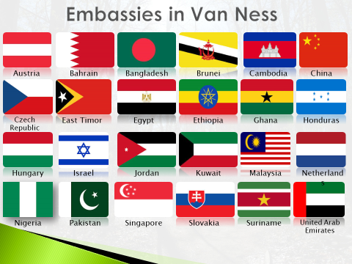

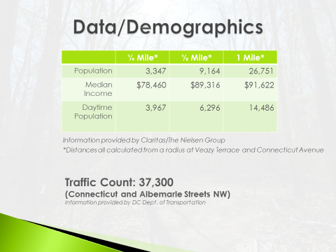

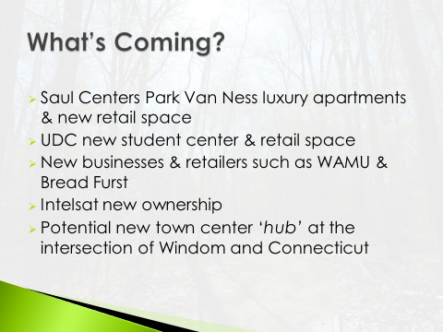

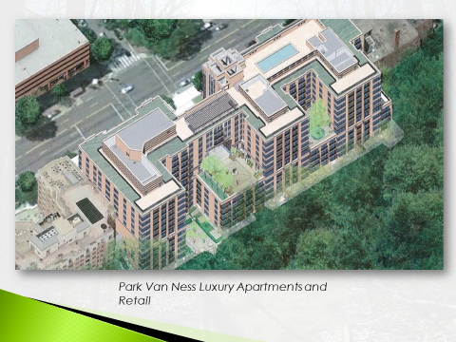

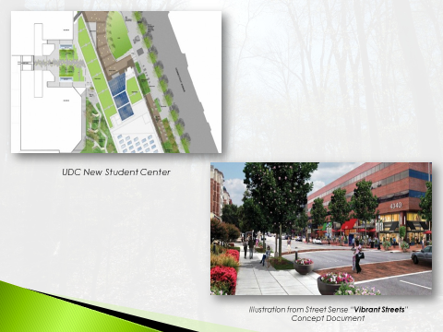

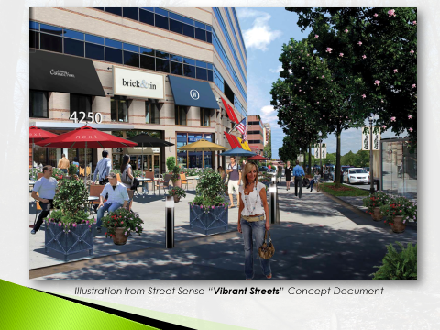

Van Ness Inventory and Property Owners
(Information compiled from Street Sense data at Vibrant Streets Workshop)
Bank of America | 4201 Conn.Ave. | 2,000 | 4201 Conn Ave Owner LLC  BMS GEMSA Loan SVC LP, Chicago, IL
Van Ness Wines/Liquor | 4201 | 1,000
Pho 14 | 4201 | 1,000
Color Nails & Spa | 4215 | 1,471 | Jemal’s Van Ness LLC, DC
Embassy Cleaners | 4215 | 1,055
Sushi Para | 4221 | 2,638
7-Eleven | 4221-A | 3,085
Vacant | 4221-B | 2,613
Walgreens | 4225 | 20,188 | 4225 Conn. Ave. NW Ltd. Partnership Walgreens, Deerfield, IL
Chalin’s Oriental Cuisine | 4250 | 1,400 | Fannie Mae & WMATA, DC
Epicurean & Co. | 4250 | 3,000
Starbucks | 4250 | 1,000
Vacant | 4250 | 2,000
Potbelly | 4300 | 1,650
CVS | 4301 | 4,000 | Van Ness Center LP Polinger Co., Chevy Chase, MD
Wells Fargo | 4302 | 1,000
Giant | 4303 | 25,000
Park Lane Cleaners | 4304 | 700 | Loftus Properties LLC Fairfax, VA
Gold’s Gym | 4310 | 19,500
Calvert Woodley Liq. | 4339 | 5,000 | Calvert Liquors, Inc. DC
Acacia Bistro | 4340 | 2,000 | UDC, District of Columbia
Vacant | 4340 | 1,200
Vacant | 4340 | 1,200
Vacant | 4340 | 1,200
Tesoro Rest. | 4400 | 2,000 | Thomas Mott Trustees, Greenbelt, MD
Subway | 4401 | 900 | American Univ. at Conn. Ave. LLC, DC
UPS | 4401 | 900
Zips | 4418 | 1,600
Burger King | 4422 | 2,000 | BB&H Joint Venture, Gaithersbg, MD
Flagship Car Wash | 4432 | 2,800 | LL Hinton, Potomac, MD
Bread Furst | 4434 | 3,300 | LL Hinton, Potomac, MD
Franklin Montessori | 4473 | 4,000
Cut n Edge Barber | 4481 | 1,000 | Nam S. Lee & Soon O. Lee Corp., Silver Spring, MD
Pad Thai | 4481 | 600
Nail Avenue | 4483 | 900
Italian Pizza Kitchen | 4483 | 1,500
Diplomat Dry Cleaners | 4483-A | 800

Links to the Forest Hills Connection articles covering the Van Ness Vision Committee: http://www.foresthillsconnection.com/category/news/vision/
Link to Washington Post article about Bread Furst and Mark Furstenberg: http://www.washingtonpost.com/lifestyle/style/master-breadmaker-mark-furstenberg-now-content-to-change-his-tiny-slice-of-the-world/2015/01/20/8c09081c-984a-11e4-8005-1924ede3e54a_story.html
And Furstenberg’s comments about Van Ness:
- “When I found an opportunity to create a bakery in this particular neighborhood, I knew what I was doing. I knew the neighborhood and was confident that it would respond to a little independent business. But I was thinking of the neighborhood purely as consumers, not as citizens.

- “I did not anticipate or even imagine getting the kind of support Bread Furst has gotten from neighborhood leaders, you who saw right away that we could add something to people’s lives here. I want you to know how much I appreciate all that you have done (and continue to do) to help this business succeed.

Link to Northwest Current article on Travis Price design concept:
http://www.currentnewspapers.com/admin/uploadfiles/NW%2011-19-2014.pdf

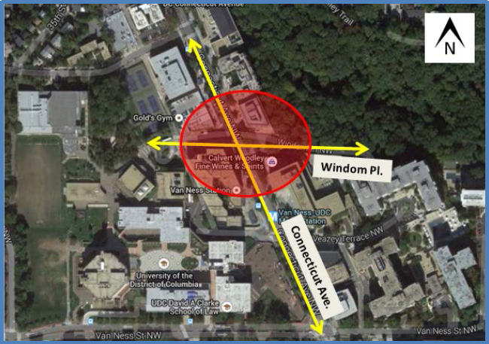
A bird’s eye view of the area identified by Office of Planning, UDC architecture students, and Travis Price Architects for the creation of a Windom Hubj (courtesy, UDC)
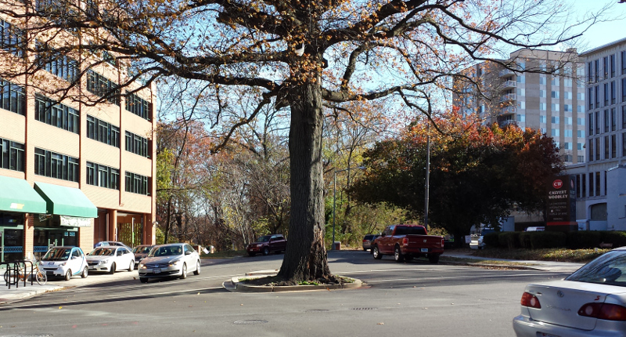
Today, looking east, the ‘warrior oak’ at Windom suggests our connection to Rock Creek Park, despite the concrete and traffic.

Looking west, Travis Price’s concept connects Soapstone Valley Park with the Windom Hub, a gathering place for people and the performing arts. The weathered copper pavilion frames the lovely view. Trees, water and stones highlight our natural surroundings and soften the streetscape. (Photo and drawing this page courtesy of Travis Price Architects)

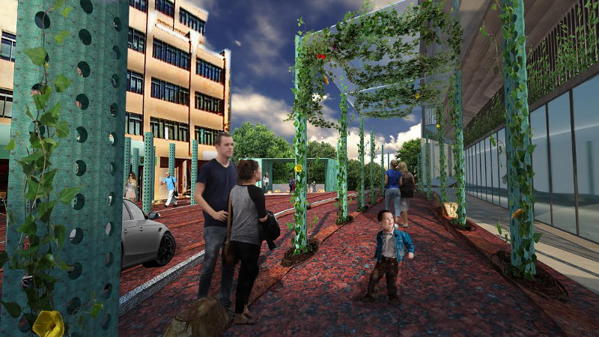
Light trees that double as trellises create a visual bridge connecting the east and west sides of Connecticut Avenue at Windom Street. (Drawings this page courtesy of Travis Price Architects)
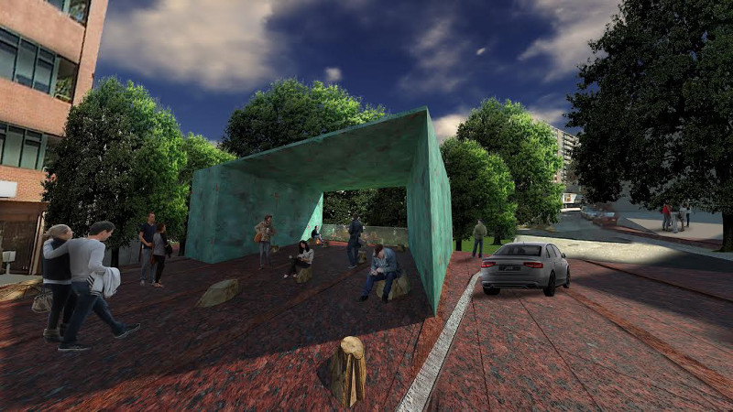
A large copper frame serves as a place for the community to gather and hear music. 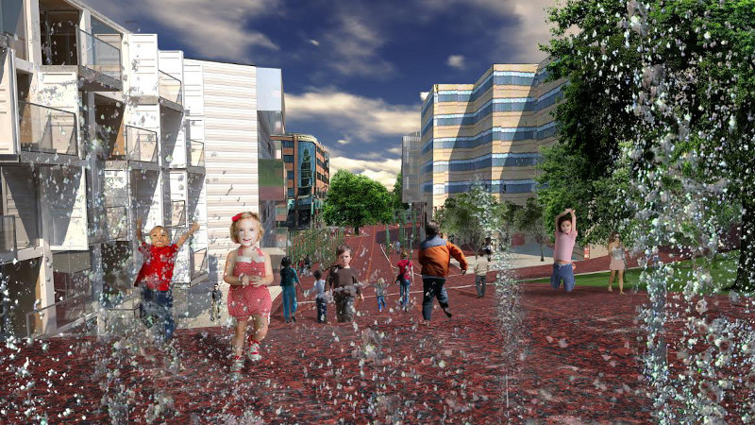
A whimsical water feature that invites interaction connects UDC’s Performing Arts Center with the Windom Hub
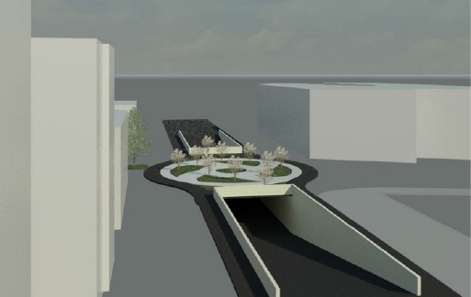
UDC School of Architecture students envision a Windom Hub, sending two of four lanes of traffic underground much like DuPont Circle (drawings on this page courtesy, UDC)
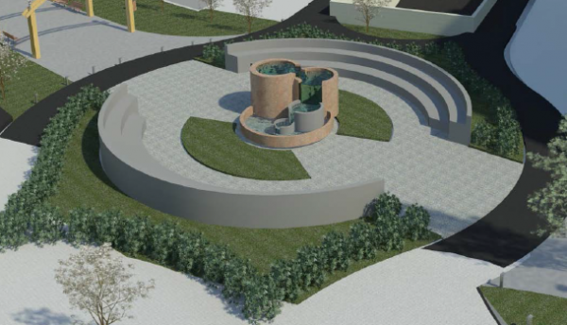
A water feature envisioned here
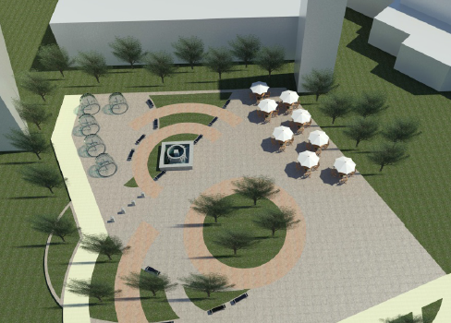
A splash park and café connect the UDC Performing Arts Center with the Windom corridor

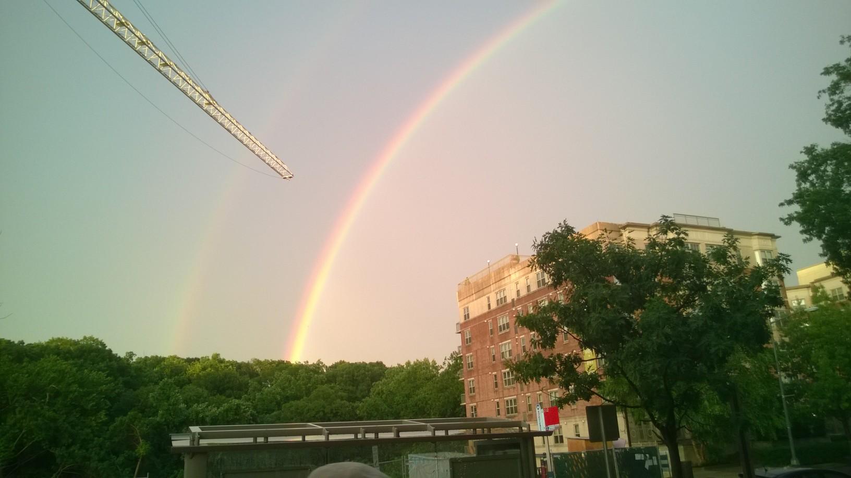
Double rainbow over Van Ness on July 8, 2014…a sign of good things to come!

Acknowledgements:
Gratitude to all the members of the Van Ness Vision Committee who contributed their time and talent so generously. Margaret Mead must have been thinking of Van Ness when she wrote: “Never doubt that a small group of thoughtful, committed citizens can change the world; indeed, it's the only thing that ever has.”
Mary Beth Ray
Chair, Van Ness Vision Committee
Commissioner, ANC 3F3
January 31, 2015
Forest Hills, Washington, D

