Soapstone at Wilson:
Status and Recommendations

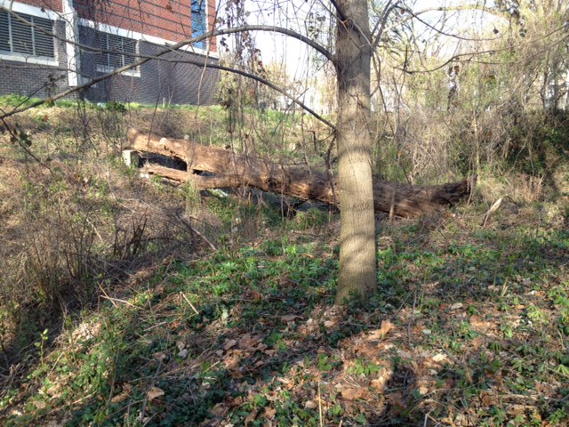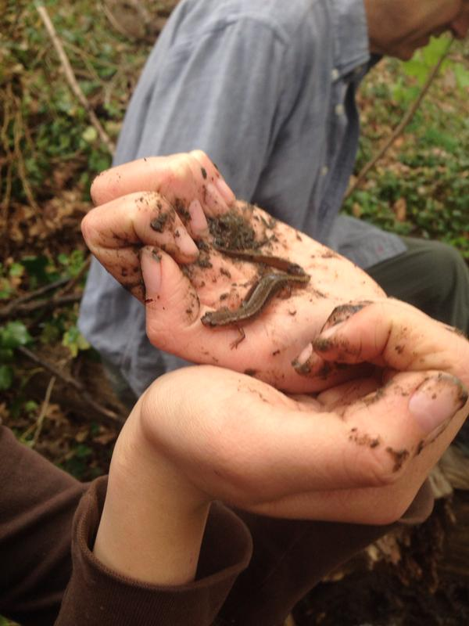

By Steve Dryden and students of Environmental Science S04-01
Woodrow Wilson High School, Washington DC, October 2015

Environmental Science S04-01 was a special honors course offered during the 2014-2015 school year. The focus was on urban ecology, using the remnant of Soapstone Creek next to the Wilson Aquatic Center as a point of study and restoration project. The course was taught by Steve Dryden, a local environmental activist and writer, who joined the adjunct faculty for that year.
Students: Tsega-Ab Abera, David Bernard, Theo Biddle, Jacob Boss, Jazmin Bunn, Elisha Crowther-Dias, Nicole Distinto, Victoria Gaetan, Nahili Hunde, Shade Kimball, Yana Madrid, Elizabeth Martu, Clare Messina-Fitzgerald, Catherine Reisert, Elena Remez, Isabella Sattler, Benjamin Wilson
Mr. Dryden would like to thank Mary Barnes, Angela Benjamin, Joe Bellino, Diana Bramble, Ana Chuquin, Gloria Gibson, Tom Miskovsky, Gabrielle Riesner, Zach Slavin, Curtis Thompson, Linda Wanner, and Cathy Wiss for their assistance during the year. Special thanks to Meg McGarry of Whole Foods Markets for arranging financial support, and Josh Rodriguez from the District Department of Energy & Environment for technical advice. Many, many thanks to Alex Wilson, academic development director at Wilson, who recognized the educational value of the Soapstone site and made the class happen.
The beautiful Soapstone Creek signs facing Fort Drive and Nebraska Avenue were designed and painted by students Amara Evering, Autumn Spears , and Kanita Wilson.

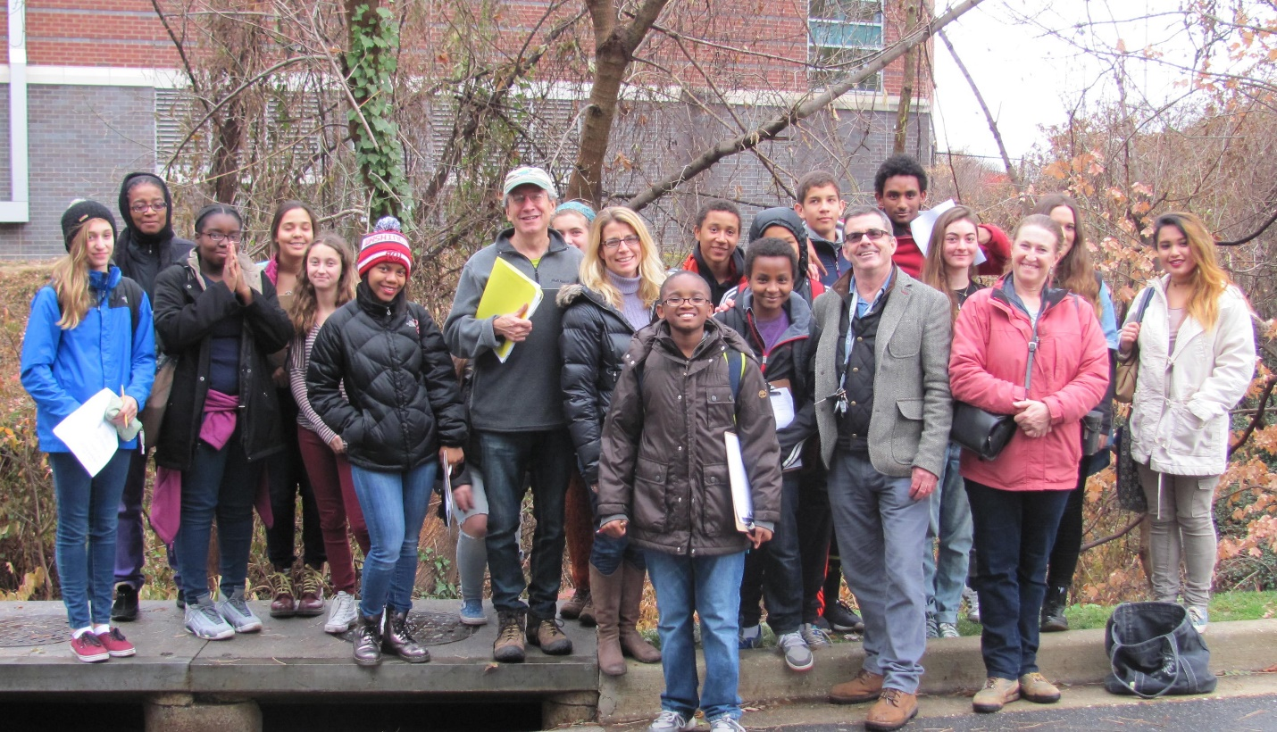

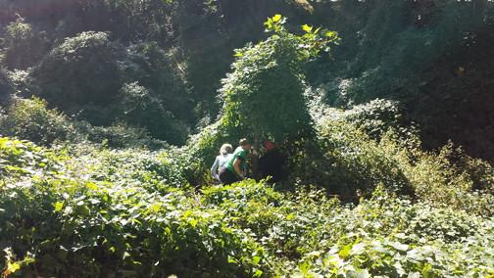
Invasive vines blanket much of the Soapstone ravine in summer 2014. Sycamore tree in center is almost completely covered.

TABLE OF CONTENTS

Introduction 4
Existing Conditions 7
Natural and Human History 11
Inventory of Flora / Fauna 14
Restoration / Management 24
Appendix 28

INTRODUCTION
By Steve Dryden

Hidden under layers of vines at the bottom of a deep ravine between the Wilson Aquatic Center and Albemarle Street is a small remnant of a major tributary of Rock Creek. Called Soapstone Creek, the tributary’s waters flow nonstop, fed mostly by a pump that discharges groundwater from around the Wilson campus buildings. Never more than a few inches deep – except during heavy rainstorms – the creek is comparatively clean, with no sewage pipe leaks that often pollute other city streams.
The creek segment and the woods around it are on land purchased by the federal government for the Fort Circle Drive system, a proposed road connecting Civil War forts -- such as nearby Fort Reno -- that form an arc across the District. Though the plan was never realized (Fort Drive, which runs in front of Wilson, got its name decades ago when the plan was still viable (ck), the properties acquired for the parkway are nominally administered by the National Park Service. As with the Civil War forts, also under Park Service administration, the properties are neglected due to lack of funding.
Long used as a dump for everything from old tires to construction debris and lawn furniture, the Soapstone ravine was adopted by Wilson faculty and students in 2000 as a possible outdoors laboratory and study area for environmental science classes. Besides having value as a small wildlife sanctuary, the site offered lessons about the natural history of Washington DC, the degradation of urban streams, and restoration techniques to repair some of the damage caused by decades of uncontrolled commercial and residential development.
The headwaters of Soapstone Creek include Tenleytown’s Fort Reno Park -- the highest point (409 feet above sea level) in Washington DC. The creek remnant next to Wilson is clearly visible on the 1862 “City of Washington” map by EG Arnold, showing Reno and other Civil War forts. The historical presence of running water is testimony to the observation of geologists that Washington is a very “wet” city with an active hydrological network that homeowners know all too well. The creek’s name refers to the soft metamorphic rock found in deposits near the stream.
Today, the Soapstone ravine at Wilson is the site of an ongoing battle between aggressive non-native plants like Japanese Knotweed, Porcelainberry and English Ivy, and such common regional wildflowers as Jewelweed, Indian Hemp and Mayapple. In mid-summer the site is deceptively lush and green, covered in many places by a blanket of invasive plants. The ravine in fact is at risk of becoming what ecologists call a biological “desert.” Essential components of the wildlife food chain -- bees, flies, moths, butterflies, caterpillars and others – can find little to eat when the plants that they evolved with over an evolutionary millenniums are unavailable. This in turn means that most birds, which depend on insect life as well as native berries and seeds for food, will also find the area unappealing. The invasive cover smothers tree seedlings and kills portions of the canopy by blocking sunlight..
For many decades the Soapstone site was in the “backyard” of a venerable 1890 home that was built by one of Tenleytown’s first family doctors, John Chappell. At the time of the home’s construction, the area was largely farmland. As Tenleytown grew into a dense commercial and residential neighborhood, the Chappell house passed through a series of owners and its condition gradually declined. The land became a sought-after prize for developers who could buy the property and maximize its value, as it was located only a half block from the entry to the Tenley Metro station.
The sale of the property in 1999, the demolishment of the Chappell house, and the developer’s plan for a 26-unit condominium complex with virtually no open space alarmed neighbors, who protested to the DC Zoning Commission. The developer eventually reduced the project to six townhouses, and secured approval. As a condition, the commission required the developer to plant new trees and protect existing ones, and assist in the removal of the invasive species.
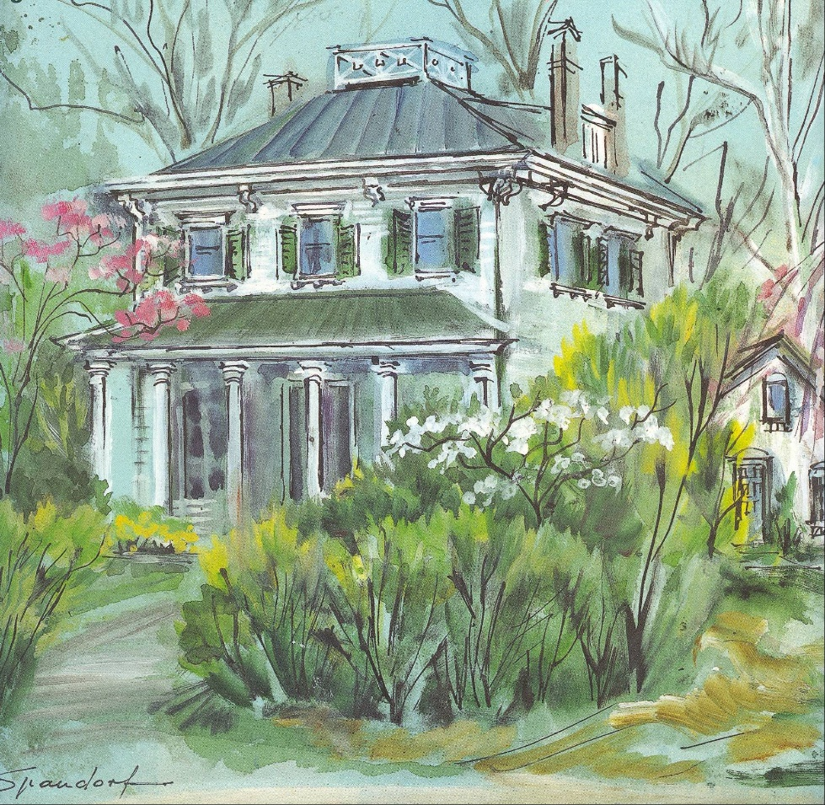
Undated painting of the John Chappell House by Washington artist Lily Spandorf

The proposed development also mobilized teachers and students at Wilson, who informally adopted the Soapstone ravine and begin removing trash and the invasive plants. Unfortunately, due to the difficulties of maintaining a purely volunteer campaign, these efforts flagged. Then, construction of the new Wilson aquatic center, whose south wall was just a few feet from the ravine, focused attention elsewhere.
By the spring of 2014, just about every square foot of the stream bank was occupied by at least one (and sometimes more) invasive species, and an enormous mats of vines were growing on any tree canopy exposed to the sun. Large amounts of trash littered the grounds and there were signs the overgrown thicket near the bus stop was being used as homeless campsite. A very large white oak, singled out for special care under the terms of the zoning agreement, was clearly dying (it was removed by the Park Service in July 2015, and an informal count of the rings on the stump put the tree’s age at 150 years).
On the plus side, the site featured a number of mature trees, ranging from tulip poplar to sycamore, and flourishing groves of native wildflowers.
In 2014, a new effort was launched in conjunction with plans for a special environmental science course on urban ecology to be offered at Wilson during the 2014-15 school year. This following report on the Soapstone site is based on research conducted by the students in that class as well as other sources.

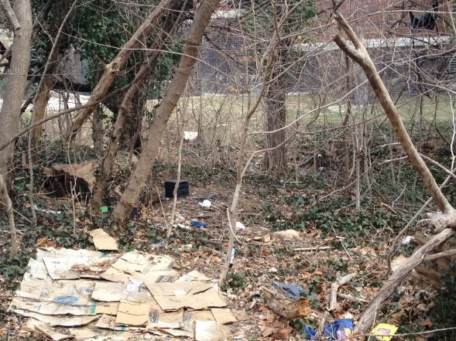
The Soapstone site in the early months of 2014

EXISTING CONDITIONS

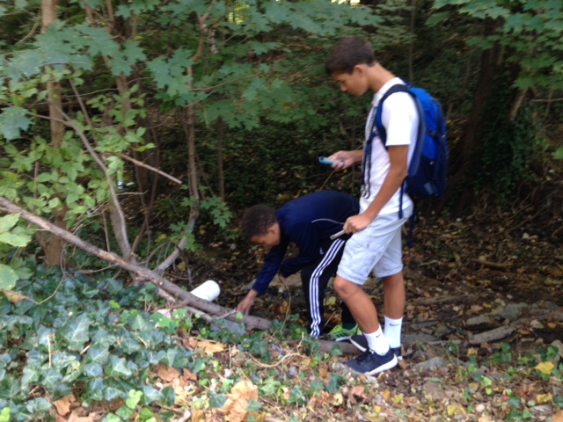
Ben Wilson and Theo Biddle time the flow rate of the pipe discharging ground water near Wilson buildings into Soapstone Creek.

Temperature of ground water discharged from pipe at Soapstone site
Data collected and compiled by Theo Biddle, Ben Wilson, and Jacob Boss
0
20
40
60
80
100
/10/
9
2014
/18/
9
2014
/19/
9
2014
/24/
9
2014
/1/
10
2014
10
/19/
2014
10
/22/
2014
10
/31/
2014
11
/7/
2014
11
/
14.2014
11
/21/
2014
/26/
11
2014
82
79
78
76
77
77
72
75
72
68
68
68

dATE

Water quality of discharge from Soapstone pipe
Data collected and compiled by Theo Biddle and Nahil Hunde

The table below presents results of water quality tests performed on the discharge into the creek from the ground water pipe. TesTab regents from the LaMotte / Earth Force water monitoring kit were used in this exercise.
Nitrate, a form of nitrogen, is a nutrient necessary for the growth of plants and animals. Too much nitrate in a waterbody overstimulates this growth, and can lead to a depletion of oxygen in the water, harming fish and other aquatic life. An overabundance of phosphates, another nutrient, can intensify oxygen depletion. The presence of excessive nutrients in water can be caused by uncontrolled lawn fertilizer use, runoff from farmland, and leakages from sewer pipes. Algae blooms have been seen in creek, which may be linked to fertilizer runoff. The low amount of oxygen cited in the table comes from ground water at the point of its discharge from the pipe. That is considered normal because the water had not been in contact with open air.

 | Date | Test results | Level | Effect on wildlife
Nitrate | Nov. 2014 | 2 ppm (parts per million) | Very low | Little Effect
Phosphate | Nov. 2014 | 4 ppm | Low | Little effect
Dissolved  Oxygen | Nov. 2014 | 4 ppm | Poor | Harmful to fish  if present
pH | Nov. 2014 | 6.5 | Slightly acidic | Satisfactory for  aquatic life
Coliform Bacteria | Nov. 2014 | Negative

Soil Analysis Report
Students collected soil samples at the Soapstone site and these were submitted for analysis by the Environmental Quality Testing Lab of the University of the District of Columbia. The results are printed below. According to the lab’s director, Dr. Tolessa Diksissa, the soil samples do not show signs of toxic contamination by heavy metals (listed under the “Environmental” table below).There were no other signs of concern, he said. The “excessive” amounts of calcium, magnesium and potassium noted in the report aren’t remarkable in a wooded, rocky area such as the Soapstone site, he added. UDC report)

Natural and Human History
Soapstone Creek joins Broad Branch creek just before Broad Branch’s confluence with Rock Creek. The watershed or drainage area covers 520 acres; however, most of that acreage is dense residential and commercial property. Approximately 15 percent of the watershed is parkland and forest in the lower reaches of the creek. The small stream at Wilson is the only remaining portion west of Connecticut Avenue. East of that road, Soapstone Creek runs about 0.9 miles through a rocky, steep-sided valley about 500 yards wide. The average channel width is approximately 15 feet and the flow rate is estimated to be about three cubic feet per second.

Tenleytown / Soapstone Creek Timeline

By Tsega Abera, Jacob Boss, and Elizabeth Martu

2000 BC: Native American Late Archaic people use the Rock Creek valley for hunting its abundant wildlife, and quarry several areas for stone that could be used for tools, weapons and cookware. They make tub-shaped cooking vessels out of the soft bedrock found along Soapstone Creek. (During 1889 – 1894, scientist William Henry Holmes of the Smithsonian Institution studied the soapstone deposits in the nearby Rose Hill Quarry -- the present day site of the University of the District of Columbia -- as part of his investigations that helped prove that the Native American presence in North America was much more recent that previously understood.)
1790: John Tennally establishes a tavern at the intersection of today’s River Road and Wisconsin Avenue, giving rise to the crossroad’s name of Tenleytown. The two roads were originally trails of the Piscataway Indians, who used them to barter with Native Americans living further north.
1805: The Maryland Assembly passes an act allowing a private company to build a turnpike road from the District line near Tenleytown to Fredericktown.

1809: D.C. commissioners declare the busy road leading from Georgetown to Tenleytown to be “a public highway.”

1817-1823: The Frederick-Georgetown road passing through Tenleytown is paved with broken stone or macadamized.

1829: A tollgate is placed at the River Road/turnpike intersection in Tenleytown. Tolls collected were 12 cents for a score of cattle; 6 cents for a score of sheep; 4 cents for one horse and rider; 6 cents for a horse and one-person carriage; and 12 cents for a four-wheeled coach with two horses.

1824-1836: Most active and lucrative years for Georgetown -- Frederick stagecoach lines.

1844: First recorded schedule of mail routes and deliveries in Tenleytown.

1861: Tenleytown, the highest point in the District, is chosen as the location for one of the major forts to defend the capital from Confederate attack. Scores of trees are cut down for wood to construct what would be named Fort Reno and provide a better line of sight for the defenders. The headwaters of Soapstone Creek are on the southern side of the fort, and the creek is used for washing, disposal of waste, and other activities by the soldiers stationed there.

July 1864: Lookouts on the signal tower at Fort Reno are the first to spot the Confederate columns headed toward Fort Stevens, on the western side of Rock Creek, for what would become the only Civil War battle fought inside Washington DC. Soldiers from Fort Reno helped to defend the approaches to Fort Stevens and the Confederate advance was beaten back.

1890: One of Tenleytown’s two doctors, John Chappell, builds a large white frame home on Grant Road (at the present day intersection of Nebraska and Albemarle). Besides dispensing medicine, Dr. Chappell also delivered babies and set broken bones. The woods behind Chappell’s house, along Soapstone Creek, become a favorite place for dice games, which were regularly broken up by police. (Helm, pg. 121)
1892 – Though Fort Reno was decommissioned after the end of the Civil War, its basic structure can still be seen 25 years later. Meanwhile, a settlement of African Americans, who first came to the fort during the war seeking safety, grows to become a village known as Reno City. Whites also lived in the modest homes arranged in a grid covering the area between Wisconsin Avenue and today’s Nebraska Avenue. Reno School is built for African American students.

1919 – The Baist Real Estate Atlas shows Soapstone Creek flowing from the land behind the Chappell house across Grant Road, the main route east from Tenleytown since the Civil War. Grant Road is lined with small detached houses, some built in the late 19th century. The creek continues downhill, though farmland including a large horse stables, toward the present-day intersection of Reno Road and Albemarle Street, which does not yet exist.

1920s – Government authorities begin condemnation proceedings to force out black residents of Reno City and make way for construction of whites-only schools, a reservoir, and radio towers. Tenleytown begins to take shape as a de facto segregated, quasi-suburban residential neighborhood with a small commercial district. Parts of Soapstone Creek near are put in pipes and paved over for stormwater control and to make room for new construction.

1934 – Construction of Wilson High School begins.

1937 – The Baist Atlas shows Albemarle and Appleton Streets have been built and property along the two streets has been divided into lots many of which are occupied by detached houses. Soapstone Creek between Nebraska and Connecticut Avenues apparently has been buried, leaving only the small headwaters segment next to Wilson.

1950s-1960s: Final wave of home building completes the transformation of Tenleytown area into a dense grid of single family dwellings and apartments.

1999: Chappell house at corner of Albemarle Street and Nebraska Avenue on lot bordering the creek is demolished by developers before neighbors can mobilize to save it. House was not on the DC Inventory of Historic Sites and thus enjoyed no protection. Developers pay $800,000 for the one-half acre property.

1999-2001: Meetings and negotiations take place between neighbors and developers over the size and scale of the proposed homes to be built on the former site of the Chappell house. An initial proposal for 26 units covering most of the lot is progressively reduced to six townhouses that, with driveways and other features, still cover about two-thirds of the lot. Numerous conditions are imposed on the development in response to the neighbors and Zoning Commission concerns. In particular, special measures are required to protect the healthy, large white oak on the northern boundary. Development is approved by Zoning Commission on July 16, 2001.

2000: Wilson students and faculty begin clean-ups of trash and removal of invasive plants from the Soapstone site. Seventeen tires, a car battery, generator, shopping cart, and a complete backgammon game are among the items found on the site. A sturdy, six-foot metal fence will later be erected along Nebraska Avenue to deter trash dumping.

2001: Soapstone site and Wilson campus are certified as a Schoolyard Habitat by the National Wildlife Federation.

Trees are planted (though where they are how many survived is unclear), and an easement is recorded to protect the site from ….

2004: The Grant Road Historic District is nominated for the National Register of Historic Places: The road “represents a rare remnant of the pre-Civil War country roads that crisscrossed rural Washington County in the District of Columbia. It retains sufficient characteristics of setting to convey the feeling of a rural road, namely its meandering character, grade changes, narrowness and its support of mid-to late 19th century vernacular building forms,” according to the DC Preservation Office nomination.

2007: The existing Wilson indoor pool next to the Soapstone site is razed to make way for the larger aquatic center. US Army Corps of Engineers delineates Soapstone Creek wetland. A drainage system is installed underground on the perimeter of the Aquatic Center, drawing water that is discharged continuously into the creek.

2014: New clean-up and restoration effort begins, in conjunction with Wilson course on urban ecology offered during the 2014-15 school year.

2015: Grey water seen flowing into creek from drain that leads back into Wilson complex. The sighting is reported to the DC Department of the Environment, which make the appropriate contacts to stop practices producing the unpermitted discharges.

2015: Dying large white oak on northern boundary line is removed. An informal count of the rings places the tree’s age at about 150 years.

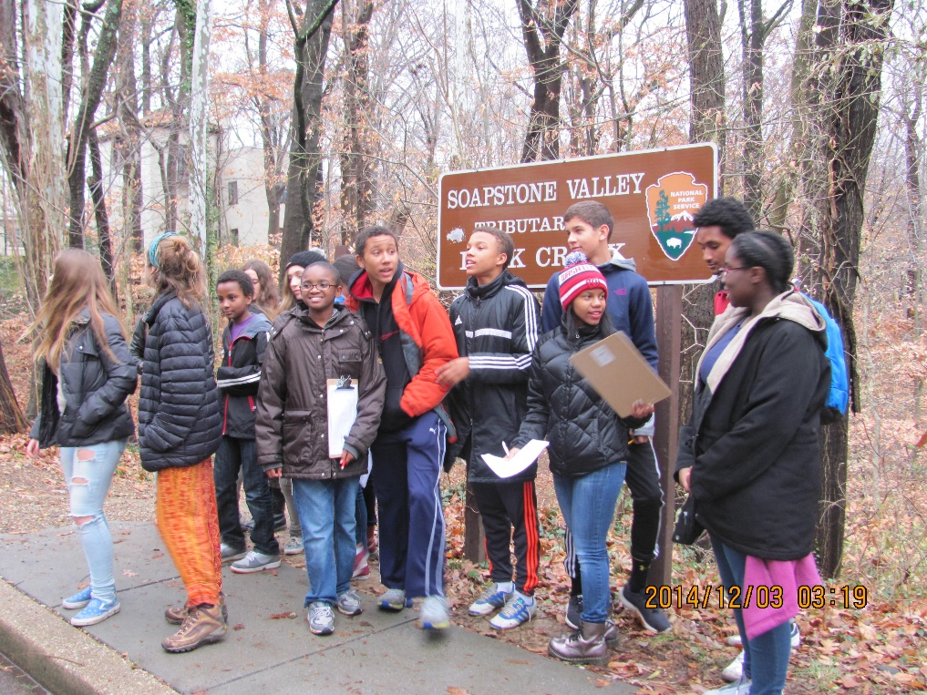
Inventory of Flora/Fauna

Trees
Surveyed by Ben Wilson; text by Steve Dryden

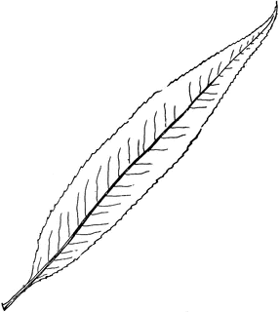
Black Willow (Salix nigra): This wetland tree is found in the open near the intake pipe that carries the creek under Nebraska Avenue. The specimen is over 20 feet and is easily identified by its narrow, lance-like, pale green leaves (example at left). Black Willow is one of the first trees to flower in the spring, featuring yellowish catkins (elongated clusters of single-sex flowers). Black Willows are, along with oaks and cherries, one of the top sources of food for insects and thus a key species for support of bird life. Researchers have identified 456 butterfly and caterpillar species that feed on this willow in the mid-Atlantic region, second only to oaks. Foliage feeders include lace bugs, beetles, weevils, and sawfly larvae. Yellow-bellied sapsuckers, a woodpecker species, drill horizontal lines of holes on the bark and feed on the sap.

White Oak (Quercus alba), Red Oak (Quercus rubra) Following the removal of the dying white oak on the southern property line, there remains one mature specimen on the Soapstone site next to the Aquatic Center. Several red oak saplings, ranging from one to five feet in height, are scattered throughout the property. Oaks in Washington DC almost qualify as an endangered species due to deer predation and the reluctance of builders and homeowners to plant this keystone species in the forest ecosystem. “Keystone” means that they have a disproportionately large effect relative to their abundance. It has been estimated that at least 534 butterfly and caterpillar species feed upon and therefore are supported by the numerous oak species in the states from Virginia to New York and Connecticut. That means oaks offer a veritable smorgasbord for birds, who must feed live insects to their young to supply the protein necessary for growth and development. Oaks also supplies valuable food in the form of acorns to a variety of wildlife, and cavities in old oak trees provide good nesting sites for many birds.

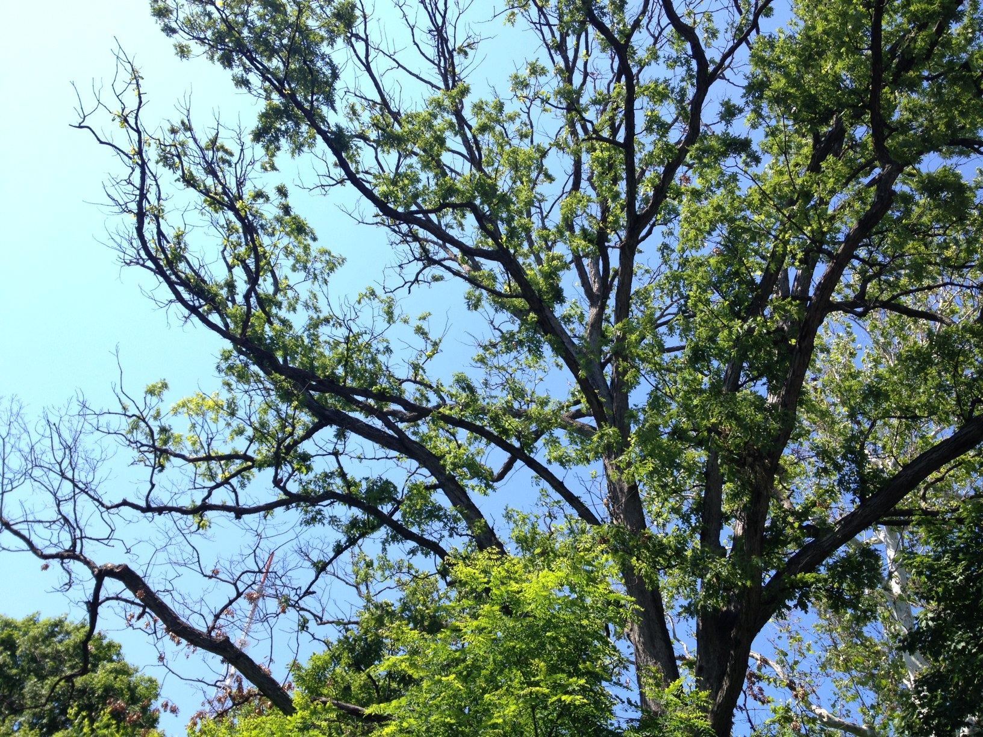
Spring 2015: Dying canopy of the white oak on the border between the Soapstone site and townhouses on Albemarle St. That summer, the National Park Service removed the tree because of the threat it posed to the homes and residents. An informal count of the rings showed it to be about 150 years old. Undisturbed white oaks have an average lifespan of 300 years.

Black Walnut (Juglans nigra): Valuable for its beautiful wood, the black walnut’s natural home is rich bottoms-lands soil and fertile hillsides. “It grew abundantly throughout the primeval hardwood forests of America. There in their days of glory it used to reach heights of 150 feet,” wrote Donald Culross Peattie in his 1950 classic, “A Natural History of Trees”. The two specimens at the Soapstone site are only about 20 feet, but do have room to grow larger if protected. “In a more innocent age,” Peattie added, gathering nuts in the autumn was the “most prized of children’s festivities … throughout the eastern (U.S.) forest belt” and walnuts were the favorite of the young collection parties. Cracking the tough shell, though, has always been a challenge, as is removing the shell’s easily transferred dark green stains.

Box Elder (Acer negundo): Known to some as the “poison ivy tree” for its superficial resemblance leaf structure (it actually has groups of five, not three leaves), the box elder is a prolific and some would say weedy tree found frequently in low-lying areas but highly adaptable to many conditions. Not surprisingly, it’s abundant on the Soapstone site. A member of the maple genus, the box elder and its cousins feed at least 285 butterfly and moth species. Easily identified in winter by its bright green branch endings.
The larvae of the Hackberry Emperor
butterfly (Asterocampa celtis) will only feed
on the leaves of the hackberry tree.

Red Maple (Acer rubrum): The red maple is the most common species on the Soapstone site, with more than 50 specimens of various sizes. The New York Times has reported: “These arboreal hard-chargers are taking over the woods. Long viewed as the maple family's poor relations, they were once confined almost exclusively to low, wet areas. Now they have burst out of the swamps and are marching into the uplands in strength.” The reason: “The rise of the red maple is part of a larger, continuing transformation of the Eastern (US) forest. The transformation has many causes, all related to humans' impact on the forest ecosystem.” Suppression of forest fires is one important factor, as maples aren’t able to withstand fires like oaks and hickories can. The maple also thrives in disturbed soil so common in the East. Maples are a popular host for the caterpillars popularly known as inchworms (68 species in eastern US forests). Very early in spring, sometimes before the March eqinox, the red maple’s flower buds – colored a striking scarlet – are easily seen against a blue sky and the tree’s grey bark. The leafstalks are also a shade of red, as are the autumn leaves.
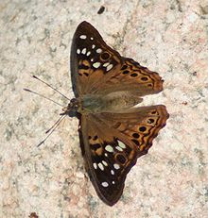
Hackberry (Celtis occidentalis): The bark of the hackberry is quite distinctive, featuring wart-like protuberances. This tree prefers moist, rich soils, and not surprisingly it is found at the Soapstone site just a few feet from the stream.
Black Locust (Robinia pseudoacacia): Considered the strongest wood to be found in North America, black locust was used to build the Jamestown settlement, and pegs made from the wood secured the boats of the American Navy in the War of 1812, according to the Colonial Williamsburg Foundation. The English quickly ceased using nails made from oak and switched to locust. “By 1820, the Philadelphia market alone was exporting between 50,000 and 100,000 locust nails to England per year,” writes Wesley Greene, garden historian at Williamsburg. Native Americans actually introduced the black locust to the eastern coast from further west, because it made strong bows. It produces large white blooms in spring with a very pleasing fragrance.
Black Cherry (Prunus serotina): The “wild” cherry tree does produce plentiful small, dark reddish fruits, but the taste is more bitter than sweet. The berries were once used to flavor rum drinks -- and today they are still eaten by a variety of animals and birds. The tree’s chief virtue is its beautiful wood, which was made into large-scale paneling when the trees were still plentiful. Now very expensive, it’s mostly used on high-end products. It’s a rapidly growing species that is one of the first to pop up in an open field, or canopy hole, and can adapt to a variety of conditions.
Red Mulberry (Morus rubra) and White Mulberry (Morus alba): Red Mulberry is native to the US and is well known for its plentiful raspberry-like berries – while the non-native white mulberry, of course, has a light green fruit. The white mulberry was imported to the US from China because it is the host plant for silkworms, and entrepreneurs hoped it would support a domestic silk industry. Though the scheme failed, the tree spread rapidly and hybridized with the red mulberry.
Catalpa: It is uncertain whether the specimen on the driveway is the Northern Catalpa (Catalpa speciose), or Southern Catalpa (Catalpa bignonioides). Both are noted for their very large, heart shaped leaves, fragrant clusters of white flowers, and brown, narrow 10-inch seed pods, which persist throughout the winter.
White Pine (Pinus strobus) : White Pine has a rich history, as it was one of the first major exports of New England colonists. Light in weight but structurally strong, white pine was valued by European nations desperate for new sources of masts for their sailing fleets. Easily carved, the pine was also used for the colorful figureheads that jutted from the front of the old sailing vessels. American farmers also leveled vast acres of white pine simply to clear land for farming, a practice that angered the British Crown, which issued numerous degrees that did little to stop the practice. Scientists have documented 277 species of insects that feed on the white pine; only 16 cause serious damage, reports the US Forest Service.
American Elm (Ulmus Americana): “An elm can scarcely hardly grow to old age without collecting rich human associations around it” according to Peattie. “If you want to be recalled for something, you will be well advised to do it under an elm – a great elm, for such a tree outlives the generations.” It’s estimated that Dutch elm disease wiped out three-quarters of all American elms in the mid-20th century.
Spicebush (Linder benzoin): This small tree gets its name from the distinctive aroma produced by a crushed leaf or broken twig. It’s one of the few native trees or shrubs deer aren’t eager to browse. The red berries are high protein fruits that appear in late summer/ early fall as migrating birds fill up in preparation for their long flight to winter homes.
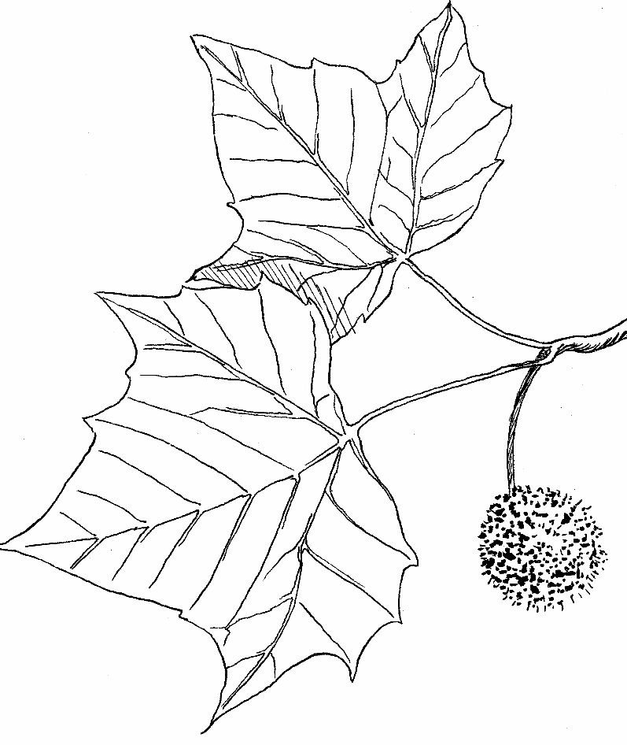
Sycamore (Plotinus occidentals): There are two large examples of this species on the Soapstone site. One is near the giant decommissioned smoke stack; the other right on the creek at the corner of the Aquatic Center. Both testify to the most predictable characteristic of the sycamore: its preference to be near water. Native Americans knew this, and used sightings to find a stream. The tree itself isn’t difficult to find because of the mottled grey/white bark, which is unlike any other native tree on in the eastern U.S. The fruits are small, bristly, brownish orbs (example at left) which eventually disintegrate, casting the seed to the wind.
Tulip Poplar, or Tulip tree (Liriodendron Tulipifera): The common name comes from its unmistakable cup-like flowers, which are distinctive yellow and orange, almost two inches wide. The tulip polar is an early “colonizer” of empty sites or a gap in a canopy. The tree trunk, ramrod straight, is soft-wooded and was hollowed out by early settlers and used as a canoe. early settlers for use as a canoe.
Herbaceous Plants
Jewelweed (Impatiens capensis): This annual wildflower – which is in the same genus as the brightly-colored, non-native impatiens available at all garden shops-- is well established along the creek in the sunny area below the Aquatic Center. It regenerates each year from seed produced by the small, bright orange flowers that begin to appear in July and continues until frost. The wildflower is also called Touch-Me-Not, for its characteristic “explosion” of tiny seed capsules when lightly brushed by hand or moved by a breeze. The juice from crushed stalks reputedly can be used to effectively treat poison ivy rash. Jewelweed flowers are an important source of nectar for the Ruby-Throated Hummingbird, our only hummingbird species on the East Coast.
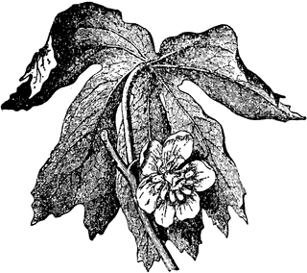
Mayapple (Podophyllum peltatum) An ephemeral ground cover, with umbrella-like leaves, that is one of the first plants to emerge in the spring. It produces a pure white flower (example at left) that later becomes an egg-shaped fruit, hence the plant’s common name. The large grove of Mayapple at the Soapstone site is an encouraging sign. Though the area becomes covered by Knotweed and Porcelainbery later in the season, the Mayapple appears to be holding its own.
Dogbane, Indian Hemp (Apocynum cannabinum) Extract from this herbaceous perennial has been used in medicinal preparation such as heart stimulants. Concentrated forms of the plant’s resins and glycosides, are toxic. The mature stems of dogbane are made of fiber used by Native American Indians used to make rope, bowstrings, nets, and thread. As with the Mayapple, the dogbane seems to have established itself strongly on one area, though it does compete with Porcelainberry throughout the season.
Daisy Fleabane (Erigeron strigosus): This annual wildflower (reproducing by seed rather than cloning) is a member of the aster family; unlike asters, however, the Daisy Fleabane blooms in spring, bringing forth large bouquets of tiny, white flowers. It’s a common plant on roadsides and other tough spots in the eastern US. Though not an insect magnet, the Daisy Fleabane’s seeds do attract goldfinches – which have been observed on the plants at the Soapstone site. It is growing vigorously along the wall of the Aquatic Center.
Winter Grape (Vitis vulpina) A native grape vine widespread in the eastern United States. The species name vulpina comes from the Latin word for "foxlike" or belonging to a fox, supposedly because the grape was attractive to foxes. The grapes’ persistence into winter as shriveled raisins make them an important cold weather food for other wildlife as well. Though the vines can climb onto the canopy of a tree, they are not considered harmful like Porcelainberry, a similar-looking but much more aggressive vine found at the Soapstone site.
Calico Aster (Symphyotrichum lateriflorum) Pollen on this aster’s small, daisy-like autumn flowers attract a wide variety of insects, including short-tongued bees, wasps, and flies, and less common visitors include long-tongued bees, small butterflies, skippers, beetles, and plant bugs. Caterpillars of the Silvery Checkerspot and Pearl Crescent butterflies feed on the foliage and flowers, as do many moth caterpillars. Heath Aster (Symphyotrichum ericoides) Similar in appearance to Calico Aster.
Goldenrod (Solidago spp.) Dismissed as a common weed, and suspected (wrongly) of being an allergen, goldenrod is in fact a very beneficial and beautiful component of any meadow or garden. Easy to grow, and tolerant of poor soil and drought, goldenrod is the generic name for more than 100 species from the aster family that are mostly native to North America. Goldenrods begin to bloom in mid-summer and continue into the fall, and its tiny, bright yellow flowers attract bumblebees, moths, and other insects that savor its nectar. Humans do, too – goldenrod can be used to make honey. It’s the state flower of Kentucky, Nebraska, and South Carolina. A patch of goldenrod can be seen on Fort Drive surrounding the Soapstone habitat restoration project sign.

Non-Native Invasive Plants
The Soapstone site has substantial infestations of several invasive plant species. The well-known English Ivy (Helix hedera) is a vine brought over in the colonial era and widely planted for ornamental purposes or to cover ground where nothing else would grow. Japanese Knotweed (Fallopia japonica), was introduced in the late 19th century as an ornamental and planted widely before it became notorious for its aggressive habits. The name refers to its concrete-like rootball. Established Knotweed is considered almost impossible to remove except with repeated use of herbicides and constant monitoring. Even then, some underground colonies may remain dormant and sprout decades later.
To round out the rogues’ gallery of noxious plants at Soapstone, there are two other Asian imports: Porcelainberry vine and an unidentified species of bamboo. This latter plant does not seem to be fast-spreading variety, but the vine is a performing in precisely the manner it’s notorious for: spreading rapidly on the ground and over small and large trees, eventually forming a thick blanket that smothers whatever is underneath. Porcelainberry is relatively easy to control on trees by just clipping the hanging vines from the ground; much more challenging is complexly removing the underground root structure.

Birds Observed at Soapstone Creek Site
Data compiled by Elena Remez and Catherine Reisert

Common Name | Latin Name | Observed by | Date | Resident Year Round / Migrant | Native to U.S. / Non-Native | Conservation Status
Northern Cardinal | Cardinalis cardinalis | Class | May 2015 | Resident | Native | Least Concern
Common Grackle | Quiscalus quiscula | Mr. Dryden | May 2015 | Resident | Native | Least Concern
American Robin | Turdus migratorius | Class | May 2015 | Resident | Native | Least Concern
Goldfinch | Spinus tristis | Mr. Dryden | May 2015 | Resident | Native | Least Concern
Red-Tailed Hawk | Buteo jamaicensis | Mr. Thompson | Nov. 2014 | Resident | Native | Least Concern
Northern  Mockingbird | Mimus polyglottos | Mr. Dryden | May 2015 | Resident | Native | Least Concern
American Crow | Corvus brachyrhynchos | Class | May 2015 | Resident | Native | Least Concern
Song Sparrow | Melospiza melodia | Mr. Dryden | May 2015 | Resident | Native | Least Concern
Grey Catbird | Dumetella carolinensis | Mr. Dryden | May 2015 | Migrant | Native | Least Concern
House Finch | Haemorhous mexicanus | Mr. Dryden | May 2015 | Resident | Introduced from West  to Eastern US in 1940s | Least Concern
Mourning Dove | Zenaida macroura | Class | May 2015 | Resident | Native | Least Concern
House Sparrow | Passer domesticus | Class | May 2015 | Resident | Non- Native  (Eurasia; North Africa) | Least Concern
Downy Woodpecker | Picoides pubescens | Mr. Dryden | June 2015 | Resident | Native | Least Concern
Carolina Wren | Thryothorus ludovicianus | Mr. Dryden | June 2015 | Resident | Native | Least Concern

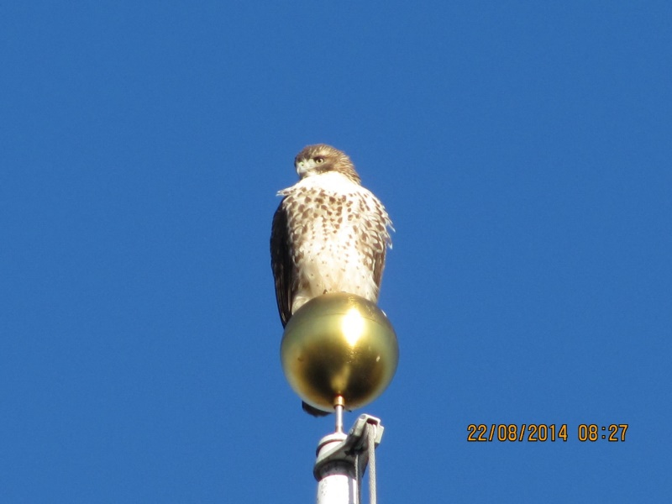
Red-Tailed Hawk Atop Wilson Flagpole
(Photo by Curtis Thompson)

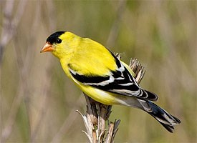
American Goldfinch

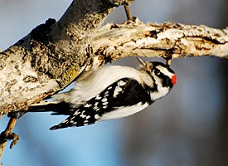
Downy Woodpecker

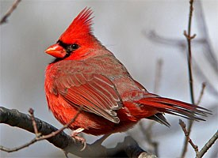
Northern Cardinal

Wildlife Observed at Soapstone Site
Data compiled by David Bernard
The absence of fish is most likely due to the isolated nature of the creek, fluctuating water levels over time, and human disturbance. Past surveys have found freshwater clams, crayfish, and phantom crane flies.

Common Name | Latin Name | Observed By | Date | Native to US? | Conservation Status
Dwarf Salamander | Eurycea  quadridigitata | Class | April 2015 | Yes | Least Concern
Eastern  Garter Snake | Thamnophis  sirtalis | Mr. Dryden | June 2015 | Yes | Least Concern
Ants, Spider, Crickets, Bees, Wasps, Beetles, Snails, Red Fly | Not identified by species | Class | Oct. 2015
Grey Squirrel | Sciurus carolinensis | Class | Oct 2014 | Yes | Least Concern
Brown Rat | Rattus norvegicus | Class | Oct. 2014 | No | Least Concern
Eastern cottontail | Sylvilagus floridanus | Mr. Dryden | June 2015 | Yes | Least Concern
Macroinvertebrates  (aquatic insects) |  | Not found
Fish |  | Not found

Dwarf Salamander (Eurycea quadridigitata) found on banks of stream.
Restoration / Management
A new round of efforts to clean up and restore the native eco-system was kicked off in April 2014, when a trash clean-up and invasive plant removal event was held at the site, with refreshments provided by Whole Foods. Both students and community members participated, removing a good deal of trash from the wooded area close to Fort Drive, which showed evidence of being used as a homeless campsite. English Ivy vines covering the trunks of several trees were cut at the base of the trees, along with Porcelainberry and other invasive plants.
Follow-up invasive plant and trash removal event were held in September, with support from Sigal Construction Corp. and Whole Foods, and in January, as part of the MLK Day of Service. These events included targeted efforts to dig up large rootballs of Japanese knotweed, and cut a large field of Porcelainberry vines covering the lower parts of the ravine. Another clean-up was held in spring 2015 with members of Mr. Dryden’s class, assisted by members of the Wilson football team, which helped break up and remove large chunks of concrete that had been dumped inside the fence along Nebraska Avenue. In the spring of 2015, several large sheets of thick black plastic, and plywood panels were placed over the areas cleared of knotweed, to prevent regrowth during the summer.
One further dumping issue concerns the large amounts of dead leaves blown from the townhouse property onto the Soapstone site. This forms a very thick layer of leaves that prevents natural regeneration of plants. It’s uncertain whether the lawn care company for the property is using fertilizers and pesticides. Use of the former is prohibited by the 2001 zoning commission order allowing the development.
In spring 2015, the Wilson Parent Teacher Student Organization applied for and was accepted as a sponsor of a Casey Trees planting on the site in spring of 2016. As part of the school planting program, Casey will provide several dozen young trees that can be planted by students and other volunteers.
Initial efforts to restore native wildflower diversity took place in early 2015, when a small area was cleared around a patch of goldenrod near the Fort Drive bus stop. The goldenrod responded in spring 2015 with vigorous sprouting. In November, 2014, students from Mr. Dryden’s class planted white wood asters, calico aster, and rough-stemmed goldenrod along the border of the site.
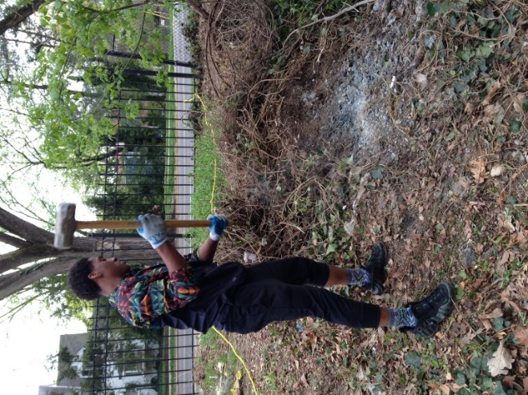
Football team member Brian Higginbotham
breaks up concrete slab dumped at Soapstone site.

Proposal for Keeping Soapstone Site Free of Trash,
and Plantings to Restore Habitat
By Clare Messina-Fitzgerald, Ellie Crowther-Diaz, and Nicole Distinto

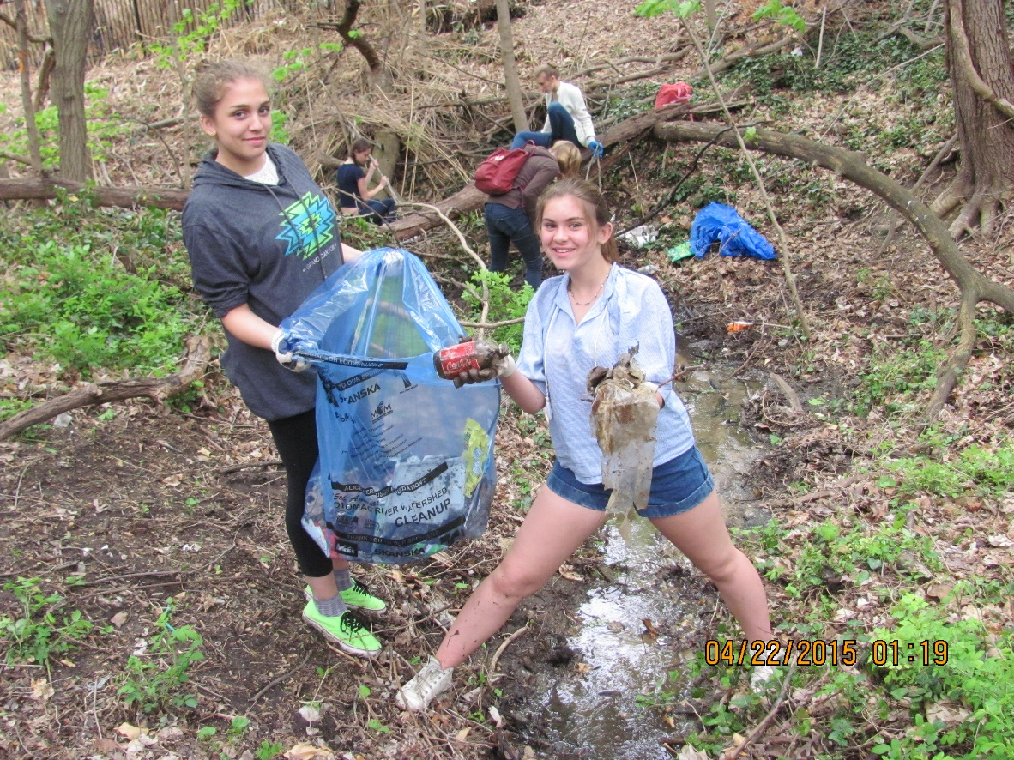

- -- There will be an independent clean-up by Environmental Science classes in future years. They will clean up the site weekly and make signs to stop people from trashing the site.

-- Individuals will be required to show photographs of trash clean-ups to get service hours.

-- Organized biweekly events will include getting rid of invasive species

-- Organized projects and volunteers assigned to check on health of planted natives species. (need photos to get service hours)

Recommended plantings at site:
Trees

- Canada Serviceberry Amelanchier canadensis (fruit attracts birds, moderate size, can tolerate some shade): Plant near creek bend.

Paw Paw Asimina triloba (moderate size, can tolerate wet conditions): Plant on stream banks.

- Eastern Red Cedar Juniperus virginiana (resistant to cold, heat and drought): Plant higher on slope of ravine.

- Black Gum or Black Tupelo Nyssa sylvatica (fruit for birds, can tolerate shade): Plant at the Nebraska side of the site.

Wildflowers

- Wild or Eastern Red Columbine Aquilegia canadensis (can tolerate part shade): Plant near the end of the stream.

- Jack-in-the-Pulpit Arisaema triphyllum (swampy areas, in shade): Plant where the creek bends and all past that along the stream.

- White Turtlehead Chelone glabra (beautiful): Plant along the fences.

- Wild Geranium Geranium maculatum (for empty spaces): Plant at dry areas cleared of invasive plants or turfgrass.

- White Wood Aster Eurybia divaricata: Plant at the ending of the creek.

- Swamp or Eastern Rose Mallow Hibiscus moscheutos: Plant at edge of wooded area.

- Virginia Bluebell Mertensia virginica (part shade) Plant near pipe that discharges into creek.

Shrubs

- Eastern Teaberry Gaultheria procumbens (interesting all four seasons): Plant at bend of creek.

- Maple Leaved Viburnum Viburnum acerifolium (disease tolerant): Plant right by the end of the stream on hill.

- Elderberry Sambucus nigra (tolerates diverse soils): Plant up near the pipe that discharges groundwater into the creek.

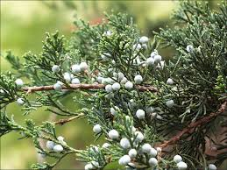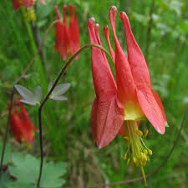
Eastern Red Cedar Wild Columbine
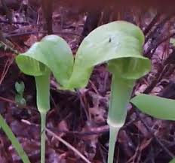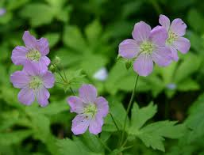

Jack-in-the-Pulpit Wild Geranium

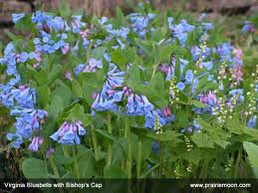

Virginia Bluebells

APPENDIX

Excerpts from DC Zoning Commission Order NO. 921 Case 00-03C (Consolidated Planned Unit Development and Zoning Map Amendment for Tenley Park LLC) September 17, 2001.

PRELIMINARY MATTERS
This proceeding initially concerned an application filed in January 2000, by Albemarle Associates, LLC (hereinafter called "Holladay") … The initial proposal was twenty-six townhouses, subsequently reduced to fourteen townhouses and later further reduced to thirteen townhouses on the north side of Albemarle Street, NW, between Fort Circle National Park and Nebraska Avenue. At its March 12, 2001 meeting, the Zoning Commission declined to vote on it, suggesting no more than seven units and environmental protections not assured by matter-of-right zoning … Subsequently, Holladay sold its land to Tenley Park, LLC, which on June 22, 2001 requested approval of six semi-detached houses (3 duplexes).
On July 9, 2001, Advisory Neighborhood Commission 3F voted unanimously to withdraw its objections to a Map Amendment, waiver of the minimum area requirement, and approval of a PUD. ANC 3F noted that Tenley Park's design differs fundamentally from and greatly improves upon the proposal the Commission declined to previously vote on. It concluded that this project, a transit-oriented cluster development, exemplifies principles underlying area-planning concepts called "Smart Growth" because it increases density on the more buildable portions of the site to allow other buildable areas to remain as open space, to preserve natural features, and to contain traffic flow. The ANC identified several public benefits and project amenities that it considered relevant to a finding of "exceptional merit and in the best interest of the city or country
At its meeting held July 16, 2001, the Zoning Commission approved the Tenley Park application.

FINDINGS OF FACT
… The houses will be set well back from the property line along Albemarle Street, more in keeping with the 3800 and 3900 blocks of that street, which will draw the eye to the trees and green space in front of the properties. The plan calls for preservation of existing mature trees in the public space, where possible, and the planting of 25 additional trees.
… The applicant has agreed to grant a conservation easement to the National Park Service (NPS) for 3,870 square feet at the rear comer of the project site, thus helping preserve some of the open space. The Commission concludes that the project's design, landscaping and preservation of open spaces are particularly strong.
…. The project will safeguard the preservation of the large white oak tree in the rear of the property, on Wilson High School property at its border with the project site. This tree is a unique and valuable resource, part of an urban forest dating back to at least the Civil War, and could live for hundreds of years. It was bound to be disturbed if not destroyed by the new construction. The applicant's buildings will be no closer than 50 feet from the tree, a distance that all parties agree is adequate to assure the trees’ continued viability.
… The applicant's design will have no significant impact on the creek. Granting a perpetual conservation easement running with the land will protect the natural drainage area from Fort Circle Park to the creek. An adequate forest buffer is important to maintaining this habitat. Riparian buffers filter runoff, help replenish ground water, and provide canopy and shade to the stream, as well as leaf food and habitat.
… The applicant plans to install a storm water management and infiltration system, with a 48" subsurface pipe one hundred feet long located at the northeast property line, near Soapstone Creek. A sand grit filter will cleanse the incoming water before it is discharged back into the creek. There will be an emergency overflow that will be hard-piped into the current closed system at Nebraska Avenue. The Commission concludes that applicant has dealt with the substantial environmental concerns of the community in a sensitive and effective manner and that this standard has been met in a particularly strong fashion that is far superior to that required for by matter-of-right development.
… Wilson HS is having Soapstone Creek certified as a Schoolyard Habitat in the National Wildlife Federation's Naturelink Program. Gloria Gibson, the chairperson of the Science Department, testified that the school intends to use the creek as an outdoor classroom/laboratory. Currently, students and members of the community have jointly cleaned up debris that accumulates in the stream valley. Tenley Park has committed to joining this effort to keep Soapstone Creek clean. If the D.C. Public Schools desire, Tenley Park may install fencing at the eastern end of Soapstone Creek to deter illegal dumping.
… Several storm pipes lead into Soapstone; soil is actively eroding at some outfalls. The applicant will place rip-rap at these storm water pipe outfalls to reduce erosion and siltation of the creek. The Commission finds that the cooperation between the applicant and the school will benefit Wilson High School students and the community, as well as preserve D.C. Public School property. This project has special value to the District of Columbia as a whole and this factor is particularly strong.
… At the request of NPS, Tenley Park will install a wrought iron decorative fence along the project site's property line with NPS property and continuing around the comer of the easement area, along the project site's property line with the D.C. Public Schools Property, and end in close proximity to the great white oak. Tenley Park will also prepare and implement a tree preservation plan to minimize disruption to NPS trees during construction. The use of fertilizers will be almost totally prohibited on the property to preserve sensitive ecological features of adjacent land.
… The conservation easement will preserve natural drainage to Soapstone Creek. A storm water management and infiltration system will recharge groundwater that feeds Soapstone Creek and its wetlands and will also remove pollutants. Trees will be planted along the banks of the creek to regulate its temperature and provide habitat for wildlife.
… Tenley Park will prepare, implement, and enforce detailed tree preservation and protection plans. These plans will include, among other things: locations and sturdiness of construction-period fences; locations of root-pruning trenches, trenching methods, and pruning methods and. at least in the case of the great white oak, will consider air space trenching and the alternatives of hand pruning or sophisticated machine pruning; and ensuring compliance.
…Tenley Park shall take the necessary steps to attempt to preserve the existing white oak tree at the rear of the project site. The six units shall be constructed at least fifty feet or more away from the white oak tree. Tenley Park will minimize impervious surfaces near the white oak tree and will prohibit vehicular and construction traffic near the tree
… Tenley Park shall install at least twenty (20) trees of native species on DCPS land to enhance vegetation shading Soapstone Creek. These species will likely be a mixture of white oaks, black oaks, sycamore and tulip poplar trees and may include eastern red cedar and black gum.
… No fertilizers shall be used on the subject site, except as may be required to protect the white oak during construction.

Syllabus ENVIRONMENTAL SCIENCE / URBAN ECOLOGY S04-01
Instructor | Steve Dryden | Phone | 301-512-5899
Classroom(s) | 425 (6th period, MWF) | E-mail | jsdryden@comcast.net
Office Hours | Monday, 3:15p – 4:00pm, or by appointment

Course Description: This is a unique opportunity to learn about the science of urban creek systems, how they have been polluted and degraded, and what can be done to restore them to more healthy conditions. Our main laboratory for learning and restoration will be the headwaters of Soapstone Creek (a tributary of Rock Creek), located next to the Wilson aquatic center. Biology, chemistry, geology, horticulture, engineering, and Washington DC history will all come into play. Several field trips will be made to off-campus Rock Creek sites. Scholars will get their hands dirty and feet wet as they plan and begin the transformation of Wilson’s mysterious piece of land and water into a wildlife sanctuary and place of relaxation.

Course Objectives:
- Understand the basic functions of an aquatic ecosystem, relate it to a city system.
- Use field work / scientific investigation to explore the Soapstone headwaters: use standard urban history research procedures to discover the original size of and changes in the Soapstone watershed.
- Match evidence and claims, provide meaningful explanations of scientific processes for the general public, and communicate appropriately to different audiences.
- Draw up a multi-year plan to restore the Soapstone headwaters; start the work.

Textbook: Arms, Environmental Science (2008)

Resources and Supplies:
Large spiral notebook, small loose leaf binder, a few pages of graph paper.
Major Assignments: Maintain a classroom/field journal; perform standard water quality tests, take an inventory of plants and animals in Soapstone area, make group presentations of findings and data, “adopt” one DC native animal or plant species for in-depth study, grow a native plant from seed in Wilson greenhouse, midterm project, and final recommendations for restoration. Also: avoid Poison Ivy!! A lovely native plant that is everywhere.

Trees near Soapstone Creek (1932)
The following trees were listed by a surveyor during the planning for construction of Wilson High School: American Elm, Ash, American Beech, American Persimmon, Black Cherry, Black Locust, Black Gum, Maple, Mulberry, Oak, Sassafras, American Sycamore, Tulip Poplar.

WORKS CITED

Eastman, John, The Book of Field and Roadside: Open-Country Weeds, Trees, and Wildflowers of Eastern North America.
Eastman, John, The Book of Swamp and Bog: Trees, Shrubs and Wildflowers of Eastern Freshwater Wetlands.
Helm, Judith, Tenleytown
Little, Elbert, The National Audubon Society Field Guide to North American Trees, Eastern Region.
Peattie, Donald Culross, A Natural History of Trees of Eastern and Central North America.
Tallamy, Douglas, Bringing Nature Home: How You Can Sustain Wildlife with Native Plants.

